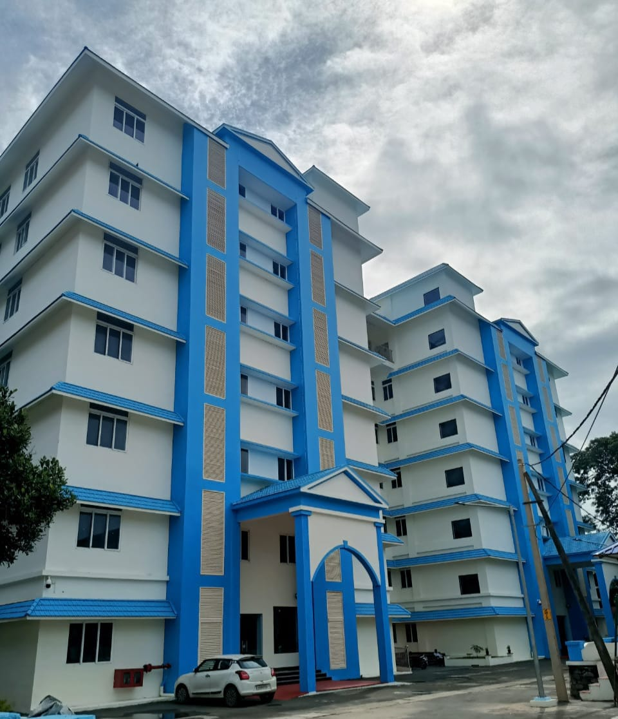
PANDEMIC PREPAREDNESS PLAN
2026
GENERAL HOSPITAL ALAPPUZHA

Dr Sandhya
Superintendent
ghalpy@gmail.com

Table of Contents
MESSAGE FROM THE CHAIRPERSON 6
MESSAGE FROM HEALTH STANDING COMMITTEE CHAIR 7
MESSAGE BY HOSPITAL SUPERINTENDENT 9
1. EXECUTIVE SUMMARY 10
2. INTRODUCTION 12
3. INSTITUTION AT A GLANCE 13
Location and Accessibility 13
4. NAVIGATION PLAN OF GH ALAPPUZHA 14
FIRE EXIT PLAN: ALL SIX FLOORS 15
PANDEMIC PREPAREDNESS FRAMEWORK 18
5. GOVERNANCE & COMMAND STRUCTURE 19
1. HOSPITAL PANDEMIC PREPAREDNESS COMMITTEE (HPPC) 19
2. INCIDENT COMMAND SYSTEM (ACTIVATED DURING PANDEMIC) 20
6. RISK ASSESSMENT 21
7. SURVEILLANCE & EARLY WARNING 22
8. CRITICAL DEPARTMENTS & 24×7 SERVICES 23
9. HOSPITAL ZONING PLAN 24
10. CATCHMENT & REFERRAL NETWORK 24
11. KEY INSTITUTIONAL FEATURES 24
1. Modern Diagnostic Facilities 24
2. Infrastructure Expansion and Modernisation 25
3. Empanelment under National Health Insurance Scheme 25
4. Emergency and Outpatient Services 25
5. Regional Referral Role 25
12. SCOPE OF FACILITY AND SURGE PREPAREDNESS 26
13. CATCHMENT AND REFERRAL NETWORK 27
14. ESCALATION & TRIGGER POINTS 27
15. GENERAL HOSPITAL ALAPPUZHA – PANDEMIC SURGE ACTION PLAN 28
1. 4S SURGE CAPACITY FRAMEWORK 28
STAFF – Human Resources Surge Plan 28
STUFF – Supplies & Equipment Surge Plan 31
STRUCTURE – Infrastructure Surge Plan 32
SYSTEM – Command, Coordination & Communication 33
Internal 33
External 34
16. GH ALAPPUZHA – TIERED SURGE ACTIVATION FRAMEWORK 35
Highlights for GH Alappuzha 36
17. DE-ESCALATION FRAMEWORK (Tier-Based Step Down) 38
Tier 3 → Tier 2 (Severe Surge → Moderate Surge) 38
Tier 2 → Tier 1 (Moderate Surge → Controlled Phase) 39
Tier 1 → Tier 0 (Return to Normal Operations) 40
18. RECOVERY PLAN – GH ALAPPUZHA 41
1. STAFF RECOVERY PLAN 41
Immediate (Within 1–2 Weeks) 41
Medium-Term (1–3 Months) 41
2. SUPPLY & EQUIPMENT REPLENISHMENT 41
3. FINANCIAL RECOVERY 41
4. AFTER ACTION REVIEW (AAR) 42
Timeline: Within 30 days of Tier 0 declaration 42
Chaired by: Medical Superintendent 42
Participants: 42
AAR Components 42
19. BIOMEDICAL WASTE MANAGEMENT FLOWCHART 43
1. STEP 1: Waste Generation 43
2. STEP 2: Segregation at Point of Generation 44
3. STEP 3: Sealing & Internal Collection 44
4. STEP 4: Internal Transport 44
5. STEP 5: Temporary Storage Area 45
6. STEP 6: Handover to Authorized CBWTF 45
7. STEP 7: Treatment & Final Disposal 45
8. STEP 8: Documentation & Reporting 45
9. STEP 9: Monitoring & Audit 45
20. EMERGENCY SPILL FLOW (Separate Mini-Flowchart) 46
21. PANDEMIC-SPECIFIC ENHANCEMENTS 46
LABORATORY PREPAREDNESS 46
The Laboratory Preparedness Plan at Women & Children Hospital Alappuzha ensures safe sample handling, accurate diagnosis, timely reporting, and strict biosafety compliance during pandemics. Through dedicated infrastructure, trained personnel, cold chain maintenance, referral laboratory coordination, and capacity expansion strategies, the hospital supports uninterrupted maternal and pediatric healthcare services while contributing effectively to public health surveillance and outbreak control. 46
1. Dedicated Sample Collection Room 46
2. Trained Staff for Sample Collection 47
3. Biosafety Measures 47
4. Triple-Layer Packaging System 47
5. Cold Chain Maintenance (2–8°C) 48
6. Tie-Up Laboratory Details 48
7. Stock Management (Test Kits, Reagents, VTM) 48
8. Sample Collection & Transport Protocol 48
9. Testing Capacity Expansion 49
10. Turnaround Time (TAT) Targets 49
11. Reporting & Data Sharing 49
12. Monitoring & Quality Control 49
22. ANNEXURES 54
ANNEXURE 1 SOPs – PANDEMIC PREPAREDNESS 54
SOP 1: TRIAGE & SCREENING OF SUSPECTED PANDEMIC PATIENTS 54
Purpose 54
To ensure early identification, segregation, and appropriate routing of suspected infectious patients. 55
Scope 55
Responsibility 55
Triage Area Setup 55
Procedure 55
SOP 2: ISOLATION WARD MANAGEMENT 56
Purpose 56
Ward Requirements 56
Staff PPE 56
Procedure 56
SOP 3: PPE DONNING & DOFFING 57
Purpose 57
Donning Steps 57
Doffing Steps (Supervised Area) 57
SOP 4: OXYGEN THERAPY & ESCALATION PROTOCOL 57
1. Purpose 57
2. Responsibility 57
3. Oxygen Escalation Steps 57
4. Monitoring 57
SOP 5: ICU/HDU MANAGEMENT 58
1. Admission Criteria 58
2. ICU Protocol 58
SOP 6: SAMPLE COLLECTION & TRANSPORT 58
1. Staff PPE 58
2. Steps 58
SOP 7: BIOMEDICAL WASTE MANAGEMENT 58
SOP 8: DEAD BODY MANAGEMENT 58
1. PPE Required 58
2. Procedure 59
SOP 10: STAFF EXPOSURE MANAGEMENT 59
Low Risk Exposure 59
High Risk Exposure 59
SOP 11: COMMUNICATION & REPORTING 59
SOP 12: CONTINUITY OF ESSENTIAL SERVICES 59
ANNEXURE 2 : IMPORTANT PHONE NUMBERS 66
Important offices of municipality/ corporation 66
Health Services 67
Helpline numbers 69
Public and Private School Contact Details 69
Information regarding resources 71
ANNEXURE 3 : LABCONTENTS 71
1. Preparation and Planning 73
2. Infection Control Measures 73
4. Sample Collection Procedure 73
Purpose 73
Responsibilities 73
Personal Protective Equipment (PPE) 74
Sample Packaging (Triple Packaging System) 74
• Used PPE and packaging disposed of as biomedical waste 74
ANNEXURE 4 : NEARBY PVT LABS 75
ANNEXURE 5: PHARMACY BUFFER STOCK 76
ANNEXURE 6 : NEARBY PHARMACIES 101
ANNEXURE 7: HR DETAILS 102
ANNEXURE 8: COMMUNICABLE DISEASE HOT SPOT 106
ANNEXURE 9: GH CIRCULAR- ESTABLISHMENT ORDER IN STRIKE 109
ANNEXURE 10: TRIAGE POLICY – HOSPITAL 110
ANNEXURE 11 : INFECTION CONTROL POLICY 112
ANNEXURE 12: DEAD BODY MANAGEMENT POLICY 113
DEAD BODY HANDLING POLICY DURING PANDEMIC PREPAREDNESS 113
Purpose 113
Scope 113
Responsibility 113
Risk Classification of Dead Body 113
General Principles 114
PPE Requirements 114
Procedure for Handling the Body 114
Immediately After Death 114
Body Preparation 114
Body Bagging 114
Transfer to Mortuary 115
Viewing by Relatives 115
Post-mortem Examination 115
Cleaning & Disinfection 115
Linen Handling 115
Transportation Outside Facility 115
Documentation Required 116
Cultural & Religious Considerations 116
Training & Mock Drills 116
Policy Review 116

MESSAGE FROM THE CHAIRPERSON
As Chairperson of the Municipality, I would like to reaffirm our unwavering commitment to the health, safety, and well-being of every resident in our community.
Recent global experiences have clearly demonstrated that pandemics can emerge unexpectedly and profoundly affect every aspect of our lives. Preparedness, therefore, is not a choice but a responsibility. Our Municipality is actively strengthening public health systems, enhancing emergency response mechanisms, and improving coordination with healthcare institutions to ensure we are ready to respond swiftly and effectively to any future health crisis.
We are investing in early warning systems, upgrading sanitation and hygiene infrastructure, and implementing measures to ensure that essential services remain uninterrupted during emergencies. Equally important is community awareness. An informed and responsible public is our strongest defense against any public health threat. I encourage all residents to follow public health guidelines, participate in awareness initiatives, and support one another—particularly the most vulnerable members of our community.
Pandemic preparedness is a shared responsibility. By working together—local government, healthcare professionals, community organizations, and residents—we can build a resilient municipality capable of facing future challenges with confidence and unity.
Let us remain vigilant, compassionate, and prepared.
Chairperson
Municipality

MESSAGE FROM HEALTH STANDING COMMITTEE CHAIR

As the Health Standing Committee Person of our Municipality, I consider the health and safety of our citizens to be our highest priority. The lessons learned from recent global and national health emergencies have clearly shown the importance of strong pandemic preparedness at the local level.
Our municipality is committed to strengthening public health infrastructure, improving disease surveillance, and ensuring prompt and coordinated responses to potential outbreaks. We are working closely with healthcare provides, frontline workers, and government agencies
Our municipality is committed to strengthening public health infrastructure, improving disease surveillance, and ensuring prompt and coordinated responses to potential outbreaks. We are working closely with healthcare providers, frontline workers, and government agencies to enhance emergency preparedness, ensure availability of essential medical supplies, and maintain continuity of critical health services during crises.
Public awareness and community participation play a vital role in pandemic preparedness. I urge residents to remain informed, practice good hygiene.
Public awareness and community participation play a vital role in pandemic preparedness. I urge all residents to remain informed, practice good hygiene, follow health advisories, and cooperate with health authorities when required. Special attention is being given to protecting vulnerable groups, including the elderly, children, and those with existing health conditions.
Preparedness today ensures safety tomorrow. By working together with responsibility, discipline, and compassion, we can build a healthier and more resilient
community capable facing future public health challenges.

HEALTH STANDING COMMITTEE MUNICIPALITY

MESSAGE BY HOSPITAL SUPERINTENDENT

We all have experienced pandemic COVID in 2020 where I myself had the opportunity to coordinate the activities of an entire district Kollam. The importance of having knowledge about the illness, route of spread, chain breaking of spread of infection, having a proper plan for activation of institution in the pandemic (disaster) mode and preparing the plan will help us in being proactive while facing the pandemic. The most crucial part of it will be executing the plan prepared in zero hour which will be possible only if we put the plan into practice by doing desktop exercise and mock drills. Each and every department should be thorough with resources, gaps and plan which will help to execute the plan to near perfection.
Pandemic preparedness plan which is prepared with help of the entire department will help us to face any disaster with minimum casualties. I really appreciate the sincerity and dedication of each and every staff who worked to make the dream come true.
Medical superintendent
GH Alappuzha

EXECUTIVE SUMMARY
This Pandemic Preparedness Plan outlines how General Hospital Alappuzha will prepare for, respond to, and recover from pandemics and large-scale infectious disease outbreaks through 2026 and beyond. As a major secondary referral centre in Alappuzha district, the hospital serves as a critical link between Primary Health Centres (PHCs), Community Health Centres (CHCs), Taluk Hospitals, and tertiary care institutions within Kerala’s public health system. The hospital plays a pivotal role in managing moderate to severe cases, stabilizing critically ill patients, and ensuring timely referral and escalation of care, while continuing to provide essential services to the surrounding population.
This plan adopts a scalable, risk-based approach aligned with the guidelines of the Directorate of Health Services, Government of Kerala, and national public health emergency management frameworks. It integrates Infection Prevention and Control (IPC), clinical service continuity, referral coordination, workforce readiness, biomedical waste management, and supply chain resilience into a unified operational framework. Clear governance structures, defined activation triggers, and an Incident Response System are established to enable rapid decision-making and effective coordination with the District Medical Office, District Surveillance Unit, and higher-level referral hospitals.
Protecting patients, healthcare workers, and the community remains a core priority. The plan emphasizes strengthened surveillance in coordination with district surveillance mechanisms, early screening and triage at entry points, dedicated fever and respiratory clinics when required, safe patient flow pathways, and clearly demarcated isolation areas to reduce healthcare-associated transmission. Special attention is given to maintaining uninterrupted inpatient, emergency, maternity, newborn, laboratory, blood bank, and essential diagnostic services during surge periods.
Workforce preparedness measures include surge staffing plans, cross-training of medical, nursing, and support staff, flexible duty rosters, reserve staffing pools, and structured occupational health and psychosocial support systems. These strategies are designed to sustain service delivery during staff shortages, increased workload, and prolonged emergency response phases.
Supply chain continuity is reinforced through buffer stock maintenance of essential medicines, personal protective equipment (PPE), oxygen supply management, critical consumables, and maintenance of essential medical equipment. Infrastructure readiness includes ensuring adequate oxygen pipeline capacity, backup power systems, and designated surge wards that can be activated when required.
The plan is strengthened through regular training programs, mock drills, simulation exercises, monitoring indicators, and periodic review to ensure continued relevance and compliance with evolving state and national guidelines.

LIST OF ABBREVIATIONS

LSGD/LSGI | Local Self Government Department / Local Self Government Institution
BMO | Block Medical Officer
ihip | Integrated health information platform
NDMA | National Disaster Management Authority
PPE | Personal Protective Equipment
ICMR | Indian Council of Medical Research
CD | Communicable Diseases
NCD | NON-COMMUNICABLE DISEASES

HOSPITALPANDEMIC PREPAREDNESS PLAN (PPP)
Facility Type: GH
Hospital Name: GH ALAPPUZHA

INTRODUCTION
General Hospital Alappuzha, also known as Government Hospital (GH) Alappuzha, is one of the oldest and most prominent public healthcare institutions in Alappuzha district, Kerala. Strategically located in the heart of Alappuzha town, the hospital has been serving the coastal and adjoining rural populations for decades, providing affordable, accessible, and quality healthcare services under the Government of Kerala.
As a major secondary care centre, the hospital delivers comprehensive outpatient and inpatient services, including 24-hour emergency care, maternal and child health services, and a wide range of specialty clinics. With a dedicated team of experienced medical officers, specialists, nursing personnel, and allied health staff, the institution plays a crucial role in delivering equitable healthcare, particularly to economically and socially vulnerable populations.
General Hospital Alappuzha functions as a Secondary Referral Centre for Taluk Headquarters Hospitals (THQH), Taluk Hospitals (TH), Community Health Centres (CHC), and Family Health Centres (FHC) within the district. The designated tertiary referral centre for advanced and super-specialty care is Government Medical College Hospital Vandanam. Through this structured referral network, the hospital ensures appropriate stabilization, management of moderate to severe cases, and timely escalation of care when required.
In addition to clinical services, the hospital actively supports national and state public health programmes, disease surveillance activities, preventive healthcare initiatives, and community outreach services. It remains a vital pillar of Kerala’s public healthcare system and a key institution in district-level health emergency response.

INSTITUTION AT A GLANCE

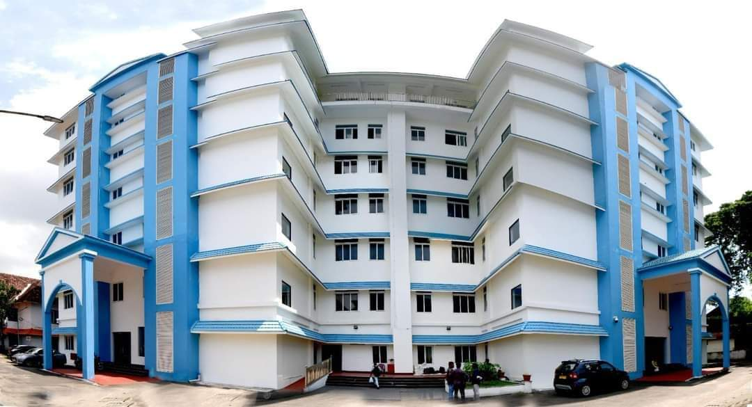

It is a government-run general hospital serving the population of Alappuzha district and nearby regions, providing affordable and accessible healthcare.
Being a Long-Standing Institution The hospital has a long history and legacy in regional healthcare, originally established during the late 19th century and progressively expanded over decades into a full-fledged district general hospital.

Location and Accessibility
General hospital is located at:
Anantha Narayanapuram,
Alappuzha, Kerala – 688011
Phone: 0477-225 3324
Email: ghalappuzha@gmail.com

NAVIGATION PLAN OF GH ALAPPUZHA
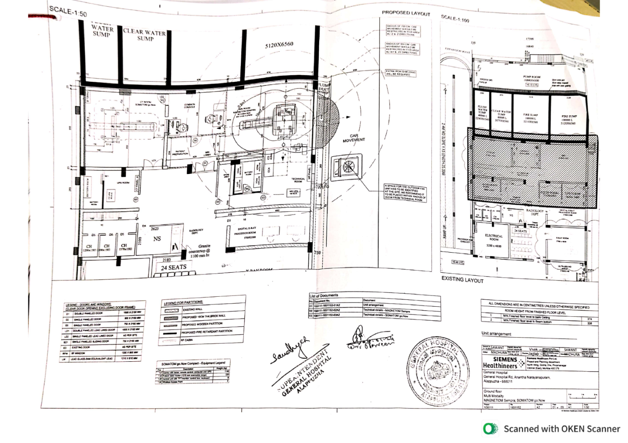

FIRE EXIT PLAN: ALL SIX FLOORS
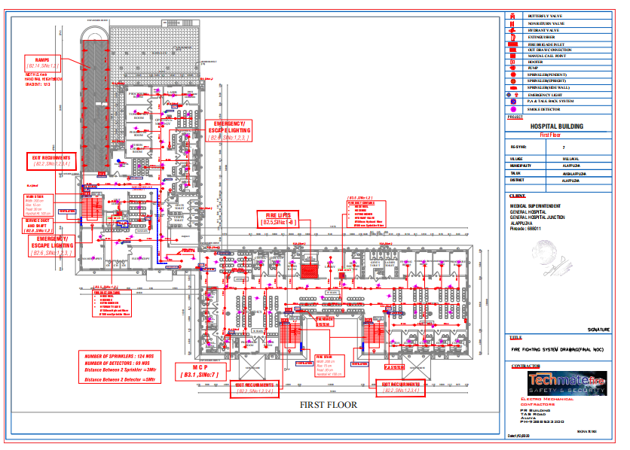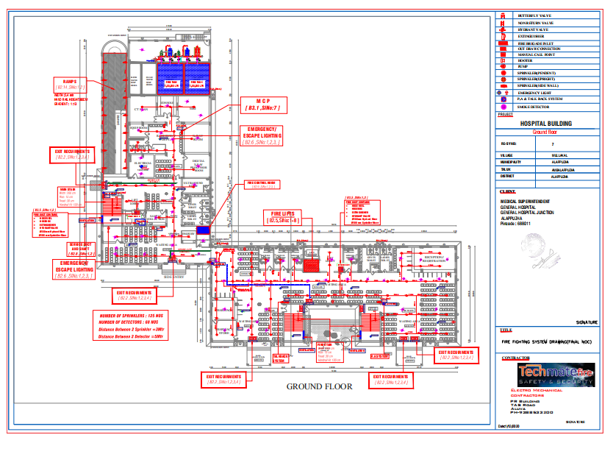
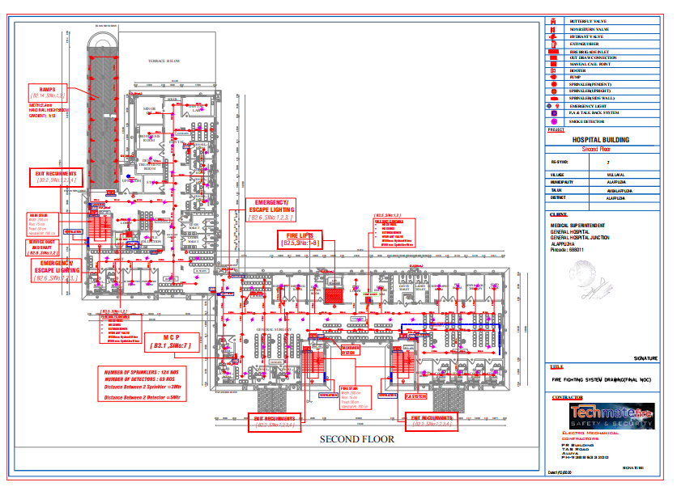
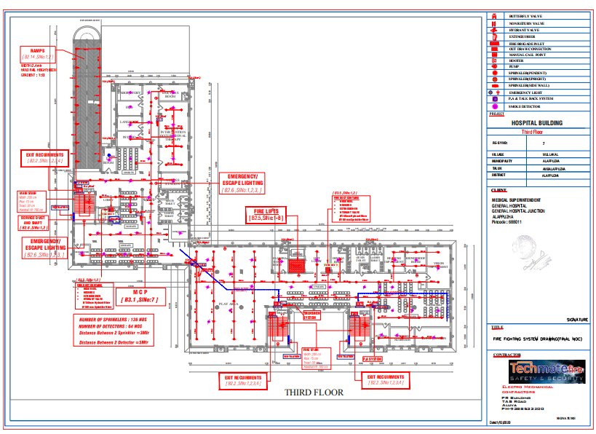

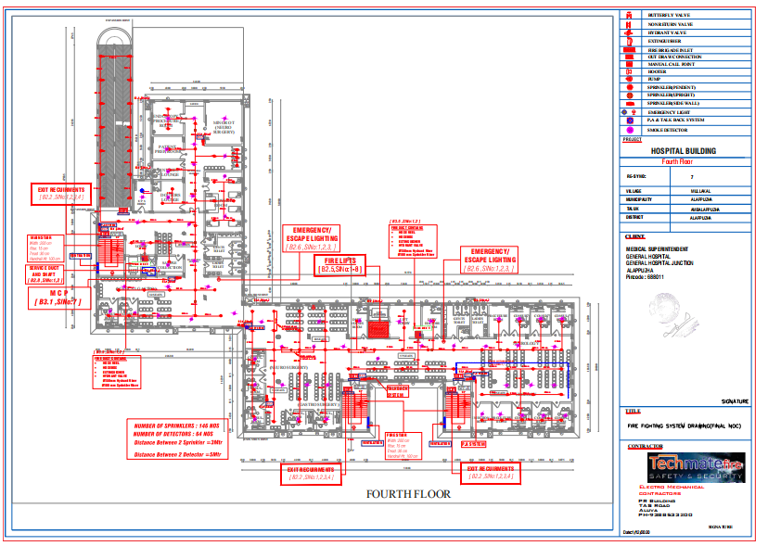
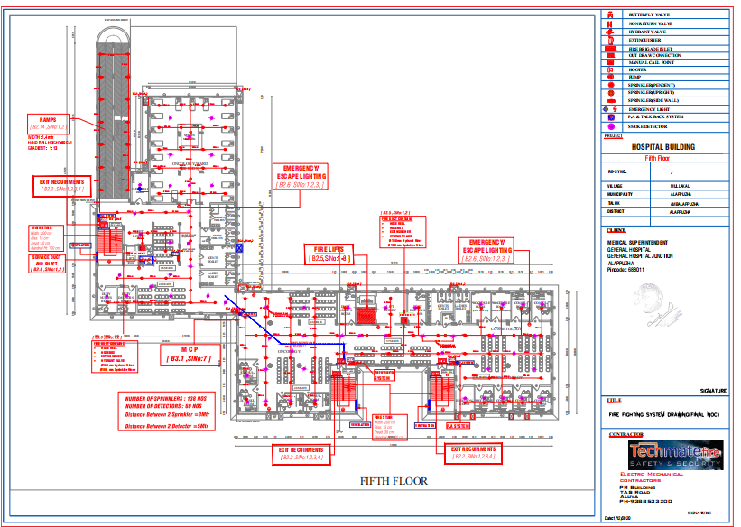
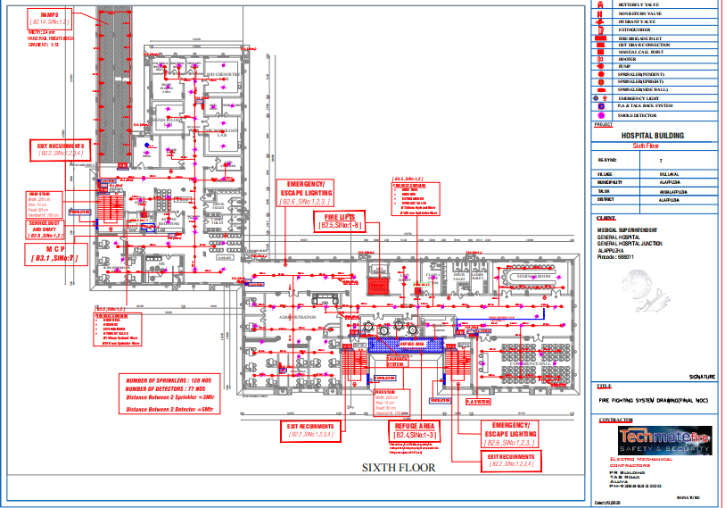

PANDEMIC PREPAREDNESS FRAMEWORK
This Pandemic Preparedness Plan has been developed to establish a comprehensive and coordinated framework for prevention, preparedness, response, and recovery during pandemics and large-scale infectious disease outbreaks. The plan aligns with national and state public health guidelines and adopts a risk-based, scalable approach tailored to the hospital’s infrastructure, service capacity, and referral responsibilities.
The framework outlines:
- Governance and incident management structures
- Infection Prevention and Control (IPC) strategies
- Surveillance, screening, and triage mechanisms
- Surge capacity planning and bed management
- Workforce contingency planning and occupational health measures
- Supply chain continuity and essential logistics management
- Internal and external communication systems
The plan prioritizes the protection of healthcare workers, patients, and visitors, while ensuring the continuity of essential services such as emergency care, maternity services, inpatient care, laboratory and diagnostic services, and critical clinical functions during periods of increased demand.
Through this structured and proactive approach, General Hospital Alappuzha aims to strengthen institutional resilience, enhance coordination with district health authorities, and remain fully prepared to safeguard public health during future pandemics and public health emergencies.

GOVERNANCE & COMMAND STRUCTURE

HOSPITAL PANDEMIC PREPAREDNESS COMMITTEE (HPPC)
Purpose: Overall planning, activation, supervision, and review of pandemic response.
DESIGNATION | NAME AND CONTACT | ROLE IN COMMITTEE | KEY RESPONSIBILITIES
Medical superintendent | Dr. Sandhya R  9744140055 | Chairperson | Final authority, coordination with district
Deputy medical superintendent | Dr Venugopal K  9447162224 | Administration | Coordinating, monitoring and implementing pandemic response strategies
PP unit incharge | Dr Praveen M  9447222512 | Overall pandemic nodal officer | Operational command and control
RMO | Dr Sen P A  9656708869 | Resource management | HR management and logistics coordination
ARMO | Dr Priyadharshan C P  9656900375 | Nodal officer | Surveillance nodal officer
ARMO | Dr Dhanya T F  8138834024 | Nodal officer | Reporting nodal officer
Physician/medicine specialist | Dr Leena K N  9446496438 | Clinical lead | Treatment protocols, ICU planning
Microbiologist/  Lab incharge | Dr Suman  7094125290  Anju (slt)  8281216859 | Lab lead | Testing & Biosafety
Nursing superintendent | Ressy P Baby  9495884490 | Nursing lead | Nursing deployment & training
Infection control officer | Indhulekha V K  9447458861 | IPC lead | PPE, Infection control audits
Housekeeping | Manju M A  9809675004 | Environmental sanitation and waste management | Infection control patient safety
PSK/ Pharmacist | Prasadu Kumar  9497774162 | Drug & supply lead | Essential drug stock
Biomedical engineer | Jyothish Thomas  9961029640 | Equipment lead | Oxygen, ventilators
Lay secretary/  Admin officer | Lakshmi  9446169835 | HR & logistics | Staffing, procurement
JHI | Jijo  9605112643 | Surveillance and early detection | Coordination, containment, public education
PRO | Benny p alosious  9645093850 | Communication | Media & public communication
Meeting Frequency:
- Monthly
- Alert Phase: Weekly
- Active Pandemic Phase: Daily briefing to Medical superintendent

INCIDENT COMMAND SYSTEM (ACTIVATED DURING PANDEMIC)

POSITION | OFFICER ASSIGNED | NAME AND CONTACT | RESPONSIBILITIES
Incident Commander | Medical Superintendent | Dr.SANDHYA R  9744140055 | Overall control
Operations Section Chief | Senior Clinician | DR LEENA K N  9446496438 | Clinical services
Logistics Section Chief | Admin Officer | DR VENUGOPAL K  9447162224 | Supplies, oxygen
Planning Section Chief | Epidemiology/Medical Officer  Nursing superintendent | DR SEN P A  9656708869  Dr PRIYADHARSHAN C P  9656900375  Dr DHANYA T F  8138834024  RESSY P BABY  9495884490 | Bed forecasting
Finance/Admin Chief | Accounts Officer | LAKSHMI  9446169835 | Funds, emergency purchase

RISK ASSESSMENT
Conduct annually and update during alerts.
PARAMETER | CURRENT STATUS |  | GAP IDENTIFIED
Catchment Population | 93912 |  | Hospital is situated in the highway and inflow of patients from various places is prevalent and hence population is not limited to the concerned ward or area.
Total sanctioned Beds | 400
Total functional Beds | 335
ICU Beds | 10
Oxygen Beds | 180+65
PSA Oxygen Plant | Yes
ICU beds with Mechanical Ventilator | 8 |  | 2 Not working
ICU beds without non-invasive Ventilator | 3
ICU beds with HFNC | NO
Lab services(timing) | 24*7
Pharmacy services | 24*7
Radiology Services |  | MRI | Yes
 |  | CT | yes
 |  | USG | yes
 |  | X-ray | yes
Blood services |  | Component separation unit | Available
 |  | Blood bank
 |  | Blood storage facility
Burns Unit | YES
24*7 Ambulance services | Available
Power Laundry | Under construction(alternate facility available)
CSSD | Available
Distance to Tertiary Centre | 10km

SURVEILLANCE & EARLY WARNING

Surveillance Officer / Designated Person
- Name: Dr. Praveen M (JC Paediatric) / PP Unit In-Charge
- Contact: 9447222512

Daily Surveillance Activities
The hospital conducts daily monitoring of key indicators to detect early warning signals for infectious disease outbreaks. Activities include:
ACTIVITY | DATA SOURCES / RESPONSIBILITY
Fever / Influenza-Like Illness (ILI) Cases | Casualty, General OP, General Medicine, Paediatrics
Severe Acute Respiratory Infection (SARI) Admissions | Nursing Superintendent Office
Healthcare Worker Illness Tracking | HR / Infection Control Unit
Cluster Detection | PP Unit MO and JHI (Public Health Wing)
Syndromic Surveillance | “S Form” – covering specific high-risk areas: AN Puram, Palace, Kaithavana, Pazhaveedu, Asramam, Mullakkal, Stadium, Pallathuruthi, District Court, Kalath, Kottankulagara, Karukayil

Screening & Entry-Point Surveillance
- Hospital Entry Kiosks: Temperature checks, hand hygiene, mask compliance (surgical/N95), gloves, PPE kits.
- Government STG Compliance: All entry screenings follow standard government protocols.
- Lab-Based Surveillance: “L Form” data collection for laboratory-confirmed cases.

Reporting Mechanisms
- Daily Data Collection: From casualty, medicine, paediatrics, and general OPD departments.
- Data Compilation & Upload: Verified data is uploaded to IHIP (Integrated Health Information Portal) following SOPs.
- Purpose: Enables timely detection of suspected and confirmed cases for public health action.
- Recipients:
  - District Surveillance Unit (IHIP)
  - District Medical Officer (DMO)

CRITICAL DEPARTMENTS & 24×7 SERVICES

Service Category | Departments / Services
Emergency & Essential Services | - Casualty (24×7)  - Lab Medicine (24×7)  - Pharmacy (24×7)  - ICU  - Anaesthesia  - Blood Bank  - Dialysis
Specialty & Super-Specialty Services | - Medicine  - Surgery  - Paediatrics,  - Obstetrics & Gynaecology,  - Ophthalmology  - ENT  - Orthopaedics  - PMR  - Respiratory Medicine  - Gastroenterology  - Oncology  - Dermatology  - Geriatrics  - NCD Clinic  - Pain & Palliative Care  - OST Services
Diagnostics | - MRI  - CT  - X-ray  - Ultrasound (USG)  - Laboratory tests  - Rapid diagnostic tests

HOSPITAL ZONING PLAN

Zone | Location | Purpose
Screening Area | Near entrance | Symptom screening
Suspect Ward | Block OLD block | Isolation for suspected
Confirmed Ward | Block OLD block | Lab-confirmed cases
ICU/HDU | Block OLD block | Severe cases
Non-Pandemic Zone | Block NEW block | Routine services
Staff accommodation | pay ward | Containment/stay

CATCHMENT & REFERRAL NETWORK

CATEGORY | FACILITIES / LABS / PHARMACIES
Government Referral Centres | - AlappuzhaGovernment Medical College Hospital Vandanam (Tertiary Referral)  - Women & Children Hospital
Private Hospitals | - Sahrudaya Hospital  - Providence Hospital  - Believers Medical Centre  - Kinder Hospital Cherthala  - Sagara Hospital Punnapra  - Sanjose Hospital Arattuvazhi
Diagnostic Labs | - DPHL  - SPHL  - NIV,Alappuzha  - DDRC Agilus Diagnostics  - Medivision, MRC Scan & Healthcare  - S Path Lab & Scan Pvt Ltd  - Sankar’s Metropolis
Pharmacies | - Neethi Pharmacy  - Karunya Community Pharmacy  - Aswin Medicals  - Kairali Medicals  - Archana Medicals

KEY INSTITUTIONAL FEATURES

Modern Diagnostic Facilities
General Hospital Alappuzha has significantly strengthened its diagnostic capabilities through the installation of advanced radiology and imaging equipment. These include:
- 1.5 Tesla MRI system
- 16-slice CT scanner
- Digital Mammography unit
- Advanced Ultrasound services
These diagnostic services are provided at government-approved rates, substantially lower than private sector costs, and are offered free of charge or highly subsidised for eligible economically disadvantaged patients. This ensures equitable access to advanced diagnostic care within the district.

Infrastructure Expansion and Modernisation
The hospital has undergone major infrastructure development with the construction of a modern multi-storey Out-Patient (OP) Block and associated facility complex. The new infrastructure includes:
- Elevator facilities for improved accessibility
- Streamlined patient flow systems
- Dedicated metabolic and specialty clinics
- Upgraded laboratory facilities
This expansion reflects sustained government investment aimed at enhancing service efficiency, patient comfort, and clinical capacity.

Empanelment under National Health Insurance Scheme
The hospital is empanelled under Ayushman Bharat Pradhan Mantri Jan Arogya Yojana (PM-JAY). Under this scheme, eligible beneficiaries are entitled to cashless and paperless treatment, including:
- Diagnostic investigations
- Surgical procedures
- Hospitalisation and ICU care
- Essential medications
Coverage is provided up to the limits defined under the scheme guidelines, thereby improving financial protection for vulnerable populations.

Emergency and Outpatient Services
General Hospital Alappuzha provides 24-hour Emergency (Casualty) services to manage acute and critical cases. In addition, scheduled outpatient specialist clinics operate on most working days, addressing a wide spectrum of acute, chronic, and non-communicable diseases. The hospital ensures continuity of care through integrated inpatient and outpatient services.

Regional Referral Role
As a major district-level secondary care institution, the hospital functions as a referral centre for complex and moderate-to-severe cases from peripheral health facilities across the Alappuzha region. It provides stabilization, specialist consultation, and, where necessary, coordinated referral to tertiary care institutions.

SCOPE OF FACILITY AND SURGE PREPAREDNESS

Surge Capacity Expansion
General Hospital Alappuzha maintains an existing bed strength of approximately 400–700 beds (combined functional capacity). In the event of a pandemic surge, the hospital will:
- Increase operational bed capacity up to 75% beyond routine occupancy levels, based on surge requirements.
- Convert identified open spaces into temporary ward areas.
- Repurpose the Nursing School auditorium and large halls into additional inpatient (IP) care areas.
- Establish clearly demarcated isolation and cohort wards, as required.
This scalable bed expansion strategy ensures the hospital can respond rapidly to increased patient load during sustained outbreaks.

Human Resource Mobilisation
To ensure continuity of services during surge periods:
- Maximum available Human Resources will be deployed strategically.
- Nursing students, volunteer staff, and retired healthcare professionals may be mobilised.
- Staff from peripheral hospitals (THQH, TH, CHC, FHC) may be temporarily reassigned as per district-level coordination.
- A structured Staff Contingency and Strike Management Policy will be implemented to maintain uninterrupted services.
- Flexible duty rosters and cross-training will support surge operations.

Essential Drugs and Supplies
- A minimum three-month buffer stock of essential medicines and emergency drugs will be maintained.
- Adequate availability of oxygen (pipeline and cylinder backup), consumables, PPE, and critical medical supplies will be ensured.
- Proactive procurement and inventory monitoring systems will be activated to prevent shortages.
- Supply chain coordination with district authorities will be strengthened during high-demand periods.

Specialty and Super-Specialty Services
All essential specialty and super-specialty services will remain operational 24 × 7, subject to surge prioritization protocols. Critical departments such as Emergency Medicine, Medicine, Surgery, Obstetrics & Gynaecology, Paediatrics, Respiratory Medicine, and ICU services will receive priority support during pandemic response phases.

CATCHMENT AND REFERRAL NETWORK

Nearest Government Referral Facilities
- Women and Children Hospital (W&C), Alappuzha
- Government Medical College Hospital Vandanam (Tertiary Referral Centre)
Category | Name of Facility
Nearest Private Hospitals | Sanjos Hospital
 | Sahrudaya Hospital
 | Providence Hospital
 | Believers Medical Centre
 | Kinder Hospital Cherthala
 | Sagara Hospital Punnapra
 | Sanjose Hospital Arattuvazhi
Nearby Diagnostic Laboratories | DDRC Agilus Diagnostics Alappuzha
 | Medivision
 | MRC Scan and Healthcare
 | S Path Lab and Scan Pvt Ltd
 | Sankar’s Metropolis
Nearby Pharmacies | Neethi Pharmacy
 | Karunya Community Pharmacy
 | Aswin Medicals
 | Kairali Medicals
 | Archana Medicals

ESCALATION & TRIGGER POINTS
Early warning triggers prompt immediate action and escalation:
TRIGGER / EVENT | ACTION REQUIRED
Any alert in IHIP | Immediate review by Surveillance Officer and escalation to DSO/DMO
Suspected cluster detected | Verification by PP Unit MO & JHI; rapid containment measures
Staff with symptoms | Validation and isolation; daily reporting to HR & Infection Control
Suspect patient in ward | Isolation and monitoring
Confirmed case | Containment measures activated, including cohorting and ward-level infection control
Staff accommodation needs | Utilize “Pay Ward” or designated staff housing for isolation/quarantine
Note: Cluster detection involves both hospital-based and community-based surveillance. Data is collected from casualty, OPD, inpatient wards, and peripheral health facilities.
TRIAGE PROTOCOL
Category | Criteria | Management Area
Mild | Fever, cough, SpO₂ ≥ 94% | Isolation ward
Moderate | Breathlessness, SpO₂ 90–93% | Oxygen ward
Severe | SpO₂ < 90%, RR > 30 | ICU/HDU

GENERAL HOSPITAL ALAPPUZHA – PANDEMIC SURGE ACTION PLAN

4S SURGE CAPACITY FRAMEWORK

STAFF – Human Resources Surge Plan

Command & Leadership Activation
Upon pandemic alert:
- Activate Hospital Pandemic Preparedness Committee (HPPC)
- Activate Incident Command System (ICS)
  - Incident Commander: Medical Superintendent
  - Daily briefing during active phase

Human Resource Mapping

Category | Available | Required in Surge | Gap | Action
Doctors
Cardiologist | 2 posts sanctioned | 4 | 2 | Deploy visiting specialists / teleconsultation; hire contractual or temporary staff
Nephrologist | 1 (working arrangement) | 2 | 1 | Request temporary deputation from district hospitals; mobilize retired staff
Neurologist | 1 post sanctioned | 2 | 1 | Contractual hiring or temporary visiting specialist
Urologist | 1 post sanctioned | 2 | 1 | Mobilize staff on rotational duty; request external support
Gastroenterologist | 1 (working arrangement) | 2 | 1 | Temporary posting / telemedicine support
Physician | 3 | 6 | 3 | Redeploy internal staff; mobilize from peripheral hospitals
Surgeon | 1 (working arrangement) | 3 | 2 | Temporary contractual surgeons; cross-train other physicians if possible
Anaesthetists | 4 | 6 | 2 | Mobilize retired anaesthetists / temporary contractual staff
Gynaecologist | 1 (working arrangement) | 2 | 1 | Temporary posting; cross-cover with obstetric-trained physicians
Paediatrician | 3 | 5 | 2 | Deploy additional staff from peripheral facilities or telemedicine support
Radiologist | 2 | 4 | 2 | Contractual radiologists or shared rotational coverage; teleradiology
Orthopaedist | 2 (1 working arrangement) | 4 | 2 | Mobilize additional specialists from peripheral hospitals
Psychiatrist | 1 | 2 | 1 | Teleconsultation or temporary deputation
Nurses | 48 (G1) + 14 (G2) + 14 (SNO) = 76 | 120 | 44 | Mobilize nursing students, volunteers, retired nurses; flexible duty rosters
Lab Technicians | 8 + 4 (NHM) = 12 | 20 | 8 | Redeploy staff, hire contractual technicians, cross-train other support staff
Pharmacists | PSK-1 + 4 (Grade1) + 2 (Grade2) + 6 (KASP) = 13 | 20 | 7 | Temporary contractual pharmacists; extend duty hours
Dialysis Technicians | 9 (KASP) | 15 | 6 | Mobilize from peripheral centers; train other staff for basic support
Housekeeping | 28 (PSC) + 30 (HMC) + 3 (PTS) = 61 | 100 | 39 | Deploy additional contractual staff; volunteers; rotate shifts for coverage

Existing Strengths
- 24×7 lab, pharmacy, radiology services
- Dedicated ICU team
- Infection Control Officer
- Public Health surveillance officer
- Nursing superintendent-led workforce

Identified Gaps
- Limited ICU ventilator capacity (2 ventilators not working)
- No HFNC
- Possible HR shortage during staff illness surge

Tier-Based Staffing Model
Level 1 (Alert Phase – 10–20% surge)
- Cancel non-urgent leave
- Reschedule elective procedures
- Cross-train ward nurses for oxygen care
- Prepare reserve duty roster
Level 2 (Moderate Surge – 20–40%)
- Convert non-clinical doctors to clinical support roles
- Reassign interns and junior residents
- Extend duty hours in shifts (8–12 hr rotation)
- Engage retired/volunteer doctors (if approved)
- Reallocate staff from low-occupancy departments
Level 3 (Severe Surge – >40%)
- Crisis staffing model:
  - 1 nurse : 4 oxygen beds
  - 1 doctor : 25 ward beds
- Fast-track training on:
  - Oxygen therapy
  - Infection control
  - Ventilator basics

Staff Protection Plan
- Strict PPE monitoring by Infection Control Officer
- Weekly HCW illness review
- Mental health support cell
- Vaccination prioritization

STUFF – Supplies & Equipment Surge Plan

Current Status
- 180 + 65 oxygen beds
- PSA plant available
- 8 working ventilators (2 not working)
- No HFNC

Immediate Actions
- Repair 2 non-functional ventilators urgently
- Procure minimum 5 HFNC machines
- Maintain 7-day oxygen buffer stock
- Daily oxygen consumption audit
- Cylinder backup arrangement

Escalation Plan
- Convert general beds to oxygen-supported beds
- Use oxygen concentrators for moderate cases
- Create oxygen triage protocol

Essential Equipment Stockpile
Minimum buffer for 4 weeks:
- PPE kits
- N95 masks
- Triple layer masks
- Gloves
- Face shields
- Viral transport media
- Rapid antigen kits
- IV fluids
- Sedatives and emergency drugs
- Broad spectrum antibiotics
- Antivirals (as per protocol)
Stock monitoring:
Daily reporting to Logistics Section Chief

ICU Expansion Equipment Plan
Current ICU beds: 10
Functional ventilators: 8
Surge Target:
- Expand ICU to 20 beds by:
  - Converting HDU / Post-op ward
  - Using anesthesia machines as ventilators
  - Borrowing ventilators from nearby facilities

STRUCTURE – Infrastructure Surge Plan

Bed Surge Plan Current:
- Total sanctioned: 400
- Functional: 335

Surge Target:
Increase to 400+ functional beds by:
- Converting:
  - Elective wards
  - Burns unit (if non-pandemic cases low)
  - OPD areas (if needed)
- Zoning:
  - Red Zone: Confirmed cases
  - Yellow Zone: Suspected cases
  - Green Zone: Non-infectious
- Separate:
  - Fever clinic
  - Respiratory triage area at entrance

Isolation Strategy
- Negative pressure (if available) for ICU
- Dedicated donning/doffing areas
- Separate entry and exit routes
- Separate staff rest areas

Utility Continuity
- PSA plant backup testing weekly
- Generator testing
- Alternate laundry (until power laundry complete)
- Biomedical maintenance daily check

SYSTEM – Command, Coordination & Communication

Command Structure
During activation:
Incident Commander → Overall control
Operations → Clinical care
Planning → Bed forecasting & surveillance
Logistics → Oxygen, drugs, supplies
Finance → Emergency procurement
Daily Command Briefing to Hospital superintendent
- Bed occupancy
- Oxygen consumption
- Staff availability
- Case trends

Surveillance & Early Warning Integration
Daily review of:
- ILI cases
- SARI admissions
- HCW illness
- Cluster detection
- Syndromic “S Form” high-risk areas
Trigger for escalation:
- 20% increase in SARI
- ICU occupancy > 80%
- Oxygen usage > 75% capacity
- HCW absenteeism > 10%

Communication Plan

Internal
- WhatsApp control group- PRO
- Daily situation report- Public health wing
- Shift handover briefing- Nursing Officer
- Dashboard display in admin block- PRO

External
- District health authority coordination- Hospital Superintendent
- Public awareness -PRO
- Media briefing only through Incident Commander- Hospital Superintendent

Documentation & Review by RMO
- Maintain pandemic logbook
- Weekly mortality review
- Monthly preparedness audit
- Post-pandemic After-Action Review
4S Component | Key Actions / Strategies | Responsible Units | Activation Trigger / Notes
STAFF (Human Resources) | - Deploy maximum in-house staff, implement surge rosters  - Cross-train clinical & non-clinical personnel  - Mobilize nursing students, volunteers, retired staff  - Deputation from peripheral hospitals (THQH, TH, CHC, FHC)  - Staff contingency & strike management | Medical Superintendent, HR, Department Heads | Triggered at >50% bed surge, absenteeism >10%
STUFF (Supplies & Equipment) | - Maintain 3-month buffer stock of essential drugs & consumables  - Ensure oxygen (pipeline + cylinders) & ventilator readiness  - PPE, disinfectants, waste disposal supplies stockpile  - Real-time inventory & supply chain coordination | Pharmacy, Biomedical Dept, Procurement, District Health Authority | Triggered when occupancy surge >50%, ICU/oxygen usage >70%
STRUCTURE (Infrastructure & Physical Space) | - Expand bed capacity by 75% beyond routine  - Convert open spaces, auditorium, halls to wards  - Establish isolation/cohort zones  - Zoning & separate patient flows (COVID/non-COVID)  - Ensure 24×7 critical departments operational | Facilities, Nursing, Dept Heads, Infection Control | Triggered when patient inflow exceeds 80% capacity or new outbreak declared
SYSTEMS (Command, Coordination & Communication) | - Activate Hospital Incident Command System (HICS)  - Daily situation reporting & surge meetings  - Coordinate with District Health Authorities, Tertiary Centres & private hospitals  - Internal staff communication & public info desks  - Monitor bed occupancy, HR, oxygen & stock | Medical Superintendent, HICS Team, Public Relations, Infection Control | Triggered immediately on outbreak notification or declaration of pandemic

GH ALAPPUZHA – TIERED SURGE ACTIVATION FRAMEWORK

TIER | TRIGGER / PATIENT LOAD | KEY ACTIONS / STRATEGIES | OUTCOME / FOCUS
Conventional | Patient load within routine bed capacity | • Continue standard hospital operations  • Minor adjustments to staffing or workflows  • Maintain regular monitoring of beds and supplies | Routine care maintained with minimal disruption
Contingency | Patient load exceeds 75% of functional beds | • Cross-train clinical and support staff  • Mobilize reserve staff, including nursing students and volunteers  • Open temporary wards by repurposing auditoriums and halls  • Implement flexible duty rosters  • Prioritize critical departments (ICU, Emergency, Paediatrics, Medicine) | Expand surge capacity while maintaining essential services
Crisis | Patient load exceeds full hospital capacity | • Activate crisis standards of care  • Repurpose all available spaces (wards, OPD, halls) for patient care  • Maximize human resources through volunteers, retired staff, and external support  • Strict triage to prioritize critical and life-saving care  • Continuous monitoring of equipment, oxygen, and ICU beds | Optimize care delivery under extreme surge conditions; protect critical resources

Highlights for GH Alappuzha
- Functional Bed Capacity: 335
- Sanctioned Beds: 400
- ICU Beds: 10 | Ventilator Beds: 4 | B-Type Oxygen Beds: 65
- Staff Mobilization: Nursing students, volunteers, retired personnel, peripheral hospital staff
- Command Activation: Hospital Incident Command System (HICS) triggers at Contingency or Crisis levels
This framework aligns beds, ventilators, ICU capacity, and staff availability with operational strategies, making it audit-ready, actionable, and easy for real-time decision-making.
BED AND SPACE EXPANSION PLAN
BED TYPE | NORMAL | SURGE LEVEL 1 | SURGE LEVEL 2
Isolation Beds | 2+10 | 200 Arranged in conference hall, floor 6 | Linked Government and Private schools, Auditoriums, community hall
Oxygen Beds | 180 | 65 | Refer to MCH Vandanam and linked Private hospitals
ICU Beds | 10+8 | 9 | Refer to MCH Vandanam and linked Private hospitals
Space Conversion Plan
- Post-op ward → Oxygen ward
- Day care → Mild case ward
- Auditorium → Step-down facility
Risk / Limitation | Context at GH Alappuzha | Mitigation Strategies
Overreliance on stockpiles | GH Alappuzha maintains essential medicines, PPE, oxygen, and consumables for routine and surge operations. Sole dependence on stored stock could fail during prolonged or multi-wave pandemics. | - Diversify suppliers at state and district levels  - Set early trigger points for conservation of critical resources (oxygen, ventilators, PPE)  - Maintain a 3-month buffer of essential medicines and consumables  - Coordinate with district health authorities for rapid resupply
Staff burnout and absenteeism | High patient inflow due to highway location and regional catchment area increases workload on doctors, nurses, and support staff, risking fatigue and absenteeism. | - Implement flexible duty rosters and shift rotations  - Mobilize reserve staff: nursing students, volunteers, retired personnel, peripheral hospital staff  - Provide psychosocial support and counselling services  - Ensure regular rest periods and wellness check-ins
Systems and protocols not practiced | Staff unfamiliarity with HICS activation, surge workflows, and infection control procedures may delay response. | - Conduct quarterly drills and simulation exercises across departments  - Implement after-action reviews to identify gaps and update protocols  - Provide ongoing training on triage, PPE usage, patient flow, and emergency communication systems
Rapid patient inflow from multiple regions | Highway location leads to non-local patients increasing risk of uncontrolled spread and overcrowding. | - Pre-triage and entry screening at all hospital access points  - Segregate high-risk and low-risk patients  - Coordinate with peripheral health centers for referral and patient diversion
Infrastructure limitations during surge | Limited ICU and ventilator beds (ICU: 10, Ventilator: 4) may be insufficient during a crisis. | - Repurpose auditoriums, halls, and open spaces for surge wards  - Prioritize critical care patients during crisis tier activation  - Coordinate with nearby government and private hospitals for patient transfers

DE-ESCALATION FRAMEWORK (Tier-Based Step Down)
De-escalation will be authorized by the Incident Commander (Medical Superintendent) in consultation with the HPPC, based on surveillance data, oxygen consumption trends, ICU occupancy, and staff availability.

Tier 3 → Tier 2 (Severe Surge → Moderate Surge)

Trigger Criteria (All Must Be Met)
- ICU/ventilator demand sustained within:
  - 10 regular ICU beds + converted contingency areas (HDU/PACU equivalent spaces)
  - For > 48 hours
- Oxygen consumption stable at < 75% PSA capacity
- No need for external reinforcement (District Rapid Response Team / State medical teams)
- HCW absenteeism < 15%
- SARI admissions declining for 5 consecutive days

Actions During Tier 3 → 2 Transition
STAFF
- Reduce crisis staffing ratios
- Restore 8-hour shifts (from 12-hour emergency shifts)
- Begin phased return of redeployed staff
- Maintain reserve pool roster
STUFF
- Maintain oxygen buffer stock (minimum 7 days)
- Continue ventilator repair & maintenance
- Maintain PPE buffer of 21 days minimum
STRUCTURE
- Decommission temporary ICU expansion beds (if census allows)
- Close overflow oxygen wards sequentially
- Terminal cleaning of deactivated areas
SYSTEM
- Reduce ICS meetings from daily to alternate-day briefings
- Continue daily surveillance reporting
- Continue district coordination

Tier 2 → Tier 1 (Moderate Surge → Controlled Phase)

Trigger Criteria
- Hospital census < 95% (i.e., < 318 occupied beds out of 335) for > 72 hours
- ICU occupancy < 70%
- Internal alternate care sites closed & terminally disinfected
- Oxygen bed occupancy < 60%
- PPE stock > 30 days available
- No new cluster from high-risk syndromic areas

Actions During Tier 2 → 1 Transition
STAFF
- Resume normal duty rosters
- Allow deferred leave in rotation
- Stop extended shifts
- Maintain surveillance team active
STUFF
- Stop emergency procurement
- Resume routine stock cycle
- Service all ventilators and oxygen equipment
- Evaluate HFNC procurement if not yet acquired
STRUCTURE
- Reopen elective wards
- Resume burns unit normal functioning (if repurposed)
- Resume OPD services fully
- Remove red/yellow zoning except isolation ward
SYSTEM
- ICS meetings weekly
- Continue weekly surveillance review
- Continue reporting to district health authorities

Tier 1 → Tier 0 (Return to Normal Operations)

Trigger Criteria
- Normal staffing ratios restored
- ED waiting time returned to baseline
- No surge admissions for > 14 days
- Oxygen usage stabilized at baseline
- ILI/SARI trend at pre-alert levels
- Elective procedures scheduled and running

Actions During Tier 1 → 0 Transition
STAFF
- Full restoration of department autonomy
- Resume training programs
- Resume student postings
- Conduct staff appreciation program
STRUCTURE
- Fully restore hospital layout
- Remove temporary donning/doffing stations
- Resume standard infection control protocols
SYSTEM
- Deactivate ICS formally
- HPPC returns to monthly review mode
- Issue public notification of normalization

RECOVERY PLAN – GH ALAPPUZHA

STAFF RECOVERY PLAN

Immediate (Within 1–2 Weeks)
- Mandatory “Recovery Off” days for ICU and COVID ward staff
- Rotate staff from high-stress units
- Psychological counselling clinic (weekly sessions)
- Debrief meetings by department

Medium-Term (1–3 Months)
- Conduct burnout assessment survey
- Recognize staff contribution publicly
- Training on resilience & stress management
- Resume CME programs

SUPPLY & EQUIPMENT REPLENISHMENT
Within 2 weeks of Tier 0:
- Full inventory audit:
  - PPE
  - Oxygen accessories
  - Drugs
  - ICU consumables
  - Rapid antigen kits
- Repair & servicing:
  - All ventilators
  - PSA plant
  - Oxygen pipelines
  - Biomedical equipment
- Restock:
  - Maintain 30-day emergency PPE stock
  - Maintain oxygen cylinder backup
  - Emergency drug cache replenished to 100%
- Update vendor contracts for emergency procurement

FINANCIAL RECOVERY
Finance/Admin Chief Responsibilities:
- Compile:
  - Emergency procurement bills
  - Oxygen expenditure
  - Temporary HR hiring records
  - Equipment repairs
- Submit reimbursement claims to:
  - State Health Department
  - National Health Mission (NHM)
  - Disaster Response Fund (if activated)
- Conduct cost analysis:
  - Cost per ICU bed expansion
  - Cost per oxygen bed
- Update emergency financial reserve requirement

AFTER ACTION REVIEW (AAR)

Timeline: Within 30 days of Tier 0 declaration

Chaired by: Medical Superintendent

Participants:
- All ICS chiefs
- Infection Control Officer
- Nursing Superintendent
- Biomedical Engineer
- Surveillance Officer
- District representative (if required)

AAR Components
- What worked well?
  - PSA plant adequacy?
  - Oxygen bed scalability?
  - Surveillance system responsiveness?
- What gaps identified?
  - ICU expansion challenges
  - HFNC absence
  - Ventilator breakdown issues
  - Staffing shortages
- Data Review:
  - Peak ICU occupancy
  - Oxygen peak consumption
  - Mortality rates
  - HCW infection rate
- Policy Updates:
  - ICU expansion plan revision
  - Minimum HFNC stock mandate
  - Emergency procurement SOP update
- Submit Final Report to:
  - District Medical Office
  - State Health Directorate

9. INFECTION PREVENTION & CONTROL (IPC)(see annexure 11 for INFECTION CONTROL POLICY)
PPE Protocol by Area
Area | PPE Required
Screening Desk | N95 + Face shield + Gloves
Isolation Ward | N95 + Gown + Gloves + Eye protection
ICU | Full PPE including coverall
Hand Hygiene
- Alcohol hand rub at all entry points
- Handwashing stations in wards
Environmental Cleaning
- High-touch areas every 2 hours
- Isolation wards every shift
- Standard precautions
- Transmission-based precautions

BIOMEDICAL WASTE MANAGEMENT FLOWCHART

STEP 1: Waste Generation
Source Points During Pandemic
- Isolation wards
- Labour rooms (suspected/confirmed cases)
- NICU & Paediatric Isolation Units
- Fever clinic
- Laboratory & Testing areas
- Operation theatres
⬇

STEP 2: Segregation at Point of Generation
Immediately at Bedside / Procedure Area
➤ Identify type of waste
➤ Dispose into colour-coded container
Colour Coding System:
- Yellow – PPE, contaminated dressings, placenta, body fluids
- Red – Tubing, IV sets, plastic disposables
- White (Translucent) – Sharps, needles
- Blue – Glassware, vials
✔ Double-layered bags for isolation areas
✔ Label as “Pandemic Infectious Waste” (if required)
✔ No mixing with general waste
⬇

STEP 3: Sealing & Internal Collection
➤ Bags sealed when ¾ full
➤ Waste handler informed
➤ Collection at scheduled intervals (increased frequency during pandemic)

Safety Measures for Waste Handlers:
- Full PPE
- No manual compression of bags
- Use of dedicated trolleys
- Separate transport route
⬇

STEP 4: Internal Transport
➤ Transport through designated pathway
➤ Avoid patient-care areas
➤ Direct transfer to temporary storage area
✔ No intermediate dumping
✔ No cross-movement through OPD zones
⬇

STEP 5: Temporary Storage Area
➤ Waste stored in secured, ventilated room
➤ Access restricted to authorized staff
➤ Disinfection of storage area daily
➤ Storage time minimized (<24 hours preferred)
✔ Pandemic waste prioritized for disposal
⬇

STEP 6: Handover to Authorized CBWTF
➤ Weight recorded
➤ Category verified
➤ Manifest form signed
➤ Waste handed over to Common Biomedical Waste Treatment Facility
⬇

STEP 7: Treatment & Final Disposal
At Authorized Facility:
Yellow → Incineration
Red → Autoclaving / Shredding
White → Sterilization & encapsulation
Blue → Disinfection & recycling (as permitted)
⬇

STEP 8: Documentation & Reporting
➤ Daily waste log updated
➤ Category-wise quantity recorded
➤ Incident/spill reports documented
➤ Monthly report to District Health Authority (if required)
⬇

STEP 9: Monitoring & Audit
➤ Infection Control Committee review
➤ Random segregation checks
➤ Staff retraining (if non-compliance observed)
➤ Corrective action implemented

EMERGENCY SPILL FLOW (Separate Mini-Flowchart)
Spill Occurs
⬇
Area cordoned
⬇
Staff wear PPE
⬇
Cover with absorbent material
⬇
Disinfect with sodium hypochlorite
⬇
Dispose as Yellow category waste
⬇
Incident recorded

PANDEMIC-SPECIFIC ENHANCEMENTS
✔ Increased collection frequency
✔ Dedicated isolation waste bins
✔ Separate storage labelling
✔ Enhanced PPE for sanitation staff
✔ Health monitoring of waste handlers

LABORATORY PREPAREDNESS

The Laboratory Preparedness Plan at Women & Children Hospital Alappuzha ensures safe sample handling, accurate diagnosis, timely reporting, and strict biosafety compliance during pandemics. Through dedicated infrastructure, trained personnel, cold chain maintenance, referral laboratory coordination, and capacity expansion strategies, the hospital supports uninterrupted maternal and pediatric healthcare services while contributing effectively to public health surveillance and outbreak control.
The purpose of this plan is to ensure safe, accurate, and timely laboratory diagnosis during a pandemic while protecting healthcare workers, patients, and the community. As a maternal and paediatric specialty hospital, laboratory preparedness is critical to support obstetric emergencies, neonatal care, paediatric infections, and outbreak containment.

Dedicated Sample Collection Room
During a pandemic, a separate and well-ventilated sample collection room is designated for suspected or confirmed infectious cases.
Key features include:
- Separate entry and exit pathways
- Physical distancing markers
- Hand hygiene station at entry and exit
- PPE donning and doffing area
- Surface disinfection after each collection
This prevents cross-contamination with routine antenatal and paediatric diagnostic services.

Trained Staff for Sample Collection
Only trained laboratory personnel or designated healthcare workers collect samples.
Training includes:
- Proper nasopharyngeal/oropharyngeal swab technique (if applicable)
- Use of PPE
- Spill management protocol
- Packaging and labelling procedures
- Exposure reporting protocol
Refresher training is conducted periodically during prolonged outbreaks.

Biosafety Measures
Strict biosafety norms are implemented as per national guidelines.
Measures include:
- Mandatory PPE (N95 mask, gloves, gown, face shield)
- Use of biosafety cabinets (Class II, where applicable)
- Surface decontamination with approved disinfectants
- Restricted laboratory access
- Daily cleaning and terminal disinfection
All laboratory activities follow Biosafety Level (BSL) requirements as applicable to the pathogen involved.

Triple-Layer Packaging System
All samples are transported using a triple-layer packaging system to prevent leakage and contamination.
The system includes:
- Primary container – Leak-proof sample tube with proper labelling
- Secondary container – Sealed, leak-proof cover with absorbent material
- Outer container – Rigid transport box labelled with biohazard symbol
Proper documentation is attached separately to avoid contamination.

Cold Chain Maintenance (2–8°C)
Samples requiring temperature control are maintained at 2–8°C during storage and transport.
Measures include:
- Use of ice packs or cold boxes
- Temperature monitoring log
- Avoiding direct contact between sample and ice
- Timely dispatch to testing laboratory
Cold chain integrity is documented to ensure test accuracy.

Tie-Up Laboratory Details
In case of limited in-house testing capacity, the hospital maintains formal coordination with:
- District Public Health Laboratory (DPHL)
- National Institute of Virology (NIV), Alappuzha, as per state referral protocol
Samples are dispatched according to district health authority instructions with proper documentation and manifest records.

Stock Management (Test Kits, Reagents, VTM)
The laboratory maintains an updated inventory of:
- Test kits
- Viral Transport Media (VTM)
- Reagents
- Consumables (swabs, tubes, pipette tips)
- PPE for lab personnel
A minimum buffer stock (e.g., 2–4 weeks based on average usage) is maintained. Daily stock monitoring is done during surge periods to prevent shortages.
Emergency procurement procedures are activated when stock levels fall below predefined thresholds.

Sample Collection & Transport Protocol
Step-by-step process:
- Patient identification and labelling
- Sample collection using PPE
- Immediate placement into primary container
- Triple-layer packaging
- Entry into laboratory register
- Cold chain maintenance
- Transport via authorized courier or designated hospital vehicle
Spill kits are kept available during transport.

Testing Capacity Expansion
During pandemic surge:
- Extended laboratory working hours
- Additional shifts for staff
- Cross-training of technicians
- Temporary deployment of trained personnel
- Coordination with district authorities for additional equipment
Capacity planning is based on anticipated case load.

Turnaround Time (TAT) Targets
The hospital aims to ensure timely reporting to support clinical decision-making.
Indicative targets:
- Routine pandemic screening tests: Within 24 hours
- Emergency obstetric/pediatric cases: Priority processing
- Referral lab reports: As per district lab timeline
Delays are documented and escalated if exceeding defined limits.

Reporting & Data Sharing
All results are:
- Entered into hospital laboratory register
- Shared with treating clinician immediately
- Reported to district surveillance system as per guidelines
- Uploaded to designated government portals (if mandated)
Confidentiality of patient information is strictly maintained.
Daily reporting summaries are submitted to hospital administration and district health authorities during active outbreak periods.

Monitoring & Quality Control
- Internal quality control checks performed daily
- External quality assurance (if applicable)
- Incident reporting for sample rejection or contamination
- Periodic audit by Infection Control Committee
Corrective actions are implemented promptly for any deviation
(DEATAILS IN ANNEXURE 3)
11. CLINICAL MANAGEMENT
Follow national/state guidelines.
Oxygen Therapy Readiness
Equipment |  | Available
Oxygen Cylinders | A type | 50
 | B type | 72
 | D type | 167
Concentrators |  | 0
Flowmeters |  | 180+15
HFNC |  | 0
11.2 ICU Preparedness
- Ventilators functional check weekly
- Backup power supply ensured
Bed/Equipment |  |  | Available
Ventilators | Mechanical Invasive |  | 8
 | C-PAP |  | 0
 | BiPAP |  | 1
ICU beds |  | ICU bed with Ventilator support | 4
 |  | ICU bed without Ventilator support | 10+8
 |  | ICU bed with centralized medical gas pipeline | 10

12. LOGISTICS & SUPPLY MANAGEMENT
Essential drug list -a curated selection of safe, effective medicines that meet the priority healthcare needs of a population, focusing on public health relevance, efficacy, safety, and cost-effectiveness, ensuring quality medicines are affordable and accessible for all. We have 736 items of drugs and consumables approved by state government. In that 517 items indented to KMSCL by the institution as per VED ANALYSIS through DDMS software

Inventory monitoring –done through DDMS software

Buffer stock policy is done in our hospital to ensure continuous patient care to avoid shortage of essential drugs

Policy used method –VED ANALYSIS

BUFFER STOCK (MINIMUM 4 WEEKS)

ITEM | DAILY USE | STOCK REQUIRED | CURRENT STOCK
PPE KITS | 2 | 120 | 105
N95 MASK | 100 | 3000 | 0
GLOVES 7 | 400 | 12000 | 4000
GLOVES 7.5 | 250 | 7500 | 34000
MASK 3 LAYER | 500 | 15000 | 28000
HAND SANITIZER | 25 | 750 | 1400
INJ.ADRENALINE | 5 | 150 | 120
AMLODIPINE TAB | 1000 | 30000 | 62000
ATROPINE INJ | 3 | 90 | 1200
CPM 4 TAB | 1000 | 30000 | 240000
CPM INJ | 5 | 150 | 1500
CLOPIDODREL 75 TAB | 400 | 12000 | 250000
DENGUE LATEX KIT | 5 | 150 | 1500
DICYCLOMINE INJ | 5 | 150 | 2500
SYRINGE 2CC | 300 | 9000 | 34000
DOXYCYCLINE 100 MG TAB | 60 | 1800 | 3300
HEPARIN INJ | 10 | 300 | 4300
I.V CANNULA 24 | 50 | 1500 | 5700
I.V SET | 150 | 4500 | 32000
INSULIN 30/70 INJ | 50 | 1500 | 2200
METFORMIN 500 | 1500 | 45000 | 600000
ORS | 50 | 1500 | 26000
PARACETAMOL INJ | 25 | 750 | 10000
PARACETAMOL TAB 500 MG | 2500 | 75000 | 1200000
RANITIDINE 150 TAB | 1500 | 45000 | 140000
DNS | 10 | 300 | 2600
NS 500 ML | 125 | 3750 | 8500
DEXTROSE 25 % | 30 | 900 | 300

Emergency drug procurement involves the rapid acquisition of medication during disaster, outbreak or sudden shortage of drugs and consumables.

Procurement –after the approval of purchase committee the drugs and consumables procured through supplycomedicals,karunyamedicals,neethi medicals etc.in our premises.
(DETAILS IN ANNEXURE5)

13. COMMUNICATION PLAN
Internal Communication
- Medical superintendent
- Deputy medical superintendent
- RMO /ARMO
- Daily situation reports to concerned staff
- Daily situation reports to staff
- Emergency WhatsApp group for disaster updates.
External Communication
- PRO responsible for media briefing
- IEC materials for public displayed
- Patient & attendant communication-PRO
- Media handling-PRO
- Risk communication
- Rumor management -PP UNIT
14. DEAD BODY MANAGEMENT
- Dedicated mortuary pathway
- Availability of freezer with capacity
- Availability of Mobile freezers
- Availability of body bags
- PPE for mortuary staff
- SOP for handing over body as per guidelines
(see annexure 12 for DEAD BODY MANAGEMENT POLICY)

15.TRAINING & MOCK DRILLS
Training Topic | Frequency | Responsible | Last convened date
PPE Donning/Doffing | Monthly | IPC Nurse
Triage Simulation | Quarterly | Emergency MO
Oxygen Failure Drill | 6 Monthly | Biomedical Engg
Triage simulation
Code Blue in PPE
Mass Casualty
Fire Attack

16. CONTINUITY OF ESSENTIAL SERVICES
Service | Continuity Plan | Alternative plans
Dialysis | Separate area & timing | Refer to MCH Vandanam, Linkage with nearby private hospitals
ANC | Dedicated OP day | Strengthen Outreach services
Immunization | Separate entry | Strengthen Outreach services
Emergency Surgery | Rapid testing before OT | Refer to MCH Vandanam, Linkage with nearby private hospitals

17. Coordination with External Agencies
- District health authorities
- Public health departments
- Private sector
- NGOs & volunteers
- Police & local administration
18.MONITORING & REVIEW
Daily Dashboard
- Isolation/Oxygen/ICU occupancy
- Oxygen consumption
- Staff availability
- PPE stock
Weekly Review
- Mortality audit
- Staff infection review
- Stock reassessment

ANNEXURES

ANNEXURE 1 SOPs – PANDEMIC PREPAREDNESS

SOP 1: TRIAGE & SCREENING OF SUSPECTED PANDEMIC PATIENTS

Purpose

To ensure early identification, segregation, and appropriate routing of suspected infectious patients.

Scope
Applies to all patients entering hospital premises during a declared pandemic.

Responsibility
- Triage Nurse
- Duty Medical Officer (DMO)
- Security Staff

Triage Area Setup
- Located at hospital entrance
- Physical barrier between staff and patient
- Hand hygiene station
- Thermal scanner
- Pulse oximeter
- Triage register

Procedure
Step
1:InitialScreening(ByNurse)
Askfor:
✔Fever
✔Cough/sorethroat
✔Breathlessness
✔Recentexposure/travel
✔ Cluster symptoms in family/workplace
Check:
- Temperature
- SpO₂
- Respiratory rate
Step 2: Categorization
Category | Criteria | Action
Mild | Fever, cough, SpO₂ ≥ 94% | Send to Isolation OP/Ward
Moderate | SpO₂ 90–93%, breathlessness | Oxygen Ward
Severe | SpO₂ < 90%, RR > 30 | ICU/HDU
Step 3: Documentation
- Enter details in Triage Register
- Inform DMO
- Provide mask to patient

SOP 2: ISOLATION WARD MANAGEMENT

Purpose
Prevent hospital transmission and provide safe care to confirmed/suspected cases.

Ward Requirements
- Separate entry/exit
- Dedicated staff
- PPE donning & doffing areas
- Biomedical waste bins (color coded)

Staff PPE
N95 mask + gown + gloves + eye protection

Procedure
Patient Admission
- Confirm triage category
- Allocate bed with minimum 1 meter spacing
- Provide patient education (mask, cough etiquette)
Monitoring
- Vitals every 4 hrs
- SpO₂ monitoring
- Early warning signs documentation
Infection Control
- No attendants unless essential
- Dedicated equipment (BP apparatus, stethoscope)
- Disinfection of surfaces every 2–4 hrs

SOP 3: PPE DONNING & DOFFING

Purpose
Prevent healthcare worker infection.

Donning Steps
- Hand hygiene
- Gown/coverall
- N95 mask
- Goggles/face shield
- Gloves (cover gown cuffs)

Doffing Steps (Supervised Area)
- Remove gloves
- Hand hygiene
- Remove gown
- Hand hygiene
- Remove eye protection
- Remove mask (last)
- Hand hygiene again
Buddy system mandatory

SOP 4: OXYGEN THERAPY & ESCALATION PROTOCOL

1. Purpose
Ensure timely oxygen therapy and prevent sudden deterioration.

2. Responsibility
Duty Doctor + Nursing Staff

3. Oxygen Escalation Steps
SpO₂ Level | Action
94%+ | Monitor
90–93% | Start oxygen via nasal prongs (2–5 L/min)
< 90% | Non-rebreather mask (10–15 L/min)
Not improving | HFNC / NIV (as per availability)
Deterioration | Shift to ICU

4. Monitoring
- SpO₂ hourly in moderate/severe
- Watch for increased RR, drowsiness

SOP 5: ICU/HDU MANAGEMENT

1. Admission Criteria
- Severe respiratory distress
- SpO₂ < 90% despite oxygen
- Altered sensorium

2. ICU Protocol
- Strict PPE
- Closed suction systems
- Minimal staff exposure
- Prone positioning as advised

SOP 6: SAMPLE COLLECTION & TRANSPORT

1. Staff PPE
N95 + gloves + gown + eye protection

2. Steps
- Verify patient ID
- Collect nasopharyngeal/oropharyngeal swab
- Place in viral transport medium
- Triple-layer packaging
- Store at 2–8°C
- Send to designated lab with form

SOP 7: BIOMEDICAL WASTE MANAGEMENT
- Use yellow bags for infectious waste
- Double bagging in isolation wards
- Label as “Pandemic Waste”
- Daily transport to BMW storage

SOP 8: DEAD BODY MANAGEMENT

1. PPE Required
Full PPE including N95, gown, gloves, face shield

2. Procedure
- Plug body orifices if required
- Wrap body in leak-proof sheet
- Disinfect outer surface
- Label clearly
- Transfer via designated route
Relatives may view body with precautions as per guidelines.
SOP 9: ENVIRONMENTAL CLEANING & DISINFECTION
Area | Frequency | Disinfectant
Triage desk | Every 2 hrs | 1% Hypochlorite
Isolation ward | Every shift | 1% Hypochlorite
ICU | 2–4 hrs | Hospital disinfectant
High-touch areas: bed rails, door handles, monitors

SOP 10: STAFF EXPOSURE MANAGEMENT

Low Risk Exposure
- Self-monitor symptoms
- Continue duty with mask

High Risk Exposure
- Home quarantine as per policy
- Testing if symptomatic

SOP 11: COMMUNICATION & REPORTING
- Daily case summary to district authority
- Immediate reporting of cluster/outbreak
- Media communication only via PRO

SOP 12: CONTINUITY OF ESSENTIAL SERVICES
- Separate zones for maternity, dialysis, emergency
- Pre-procedure screening
- Dedicated clean pathways
Area | Frequency | Disinfectant
Triage desk | Every 2 hrs | 1% Hypochlorite
Isolation ward | Every shift | 1% Hypochlorite
ICU | 2–4 hrs | Hospital disinfectant

SOP 13: CONTINUUM OF CARE FOR MAINTENANCE HEMODIALYSIS (MHD) DURING PANDEMIC
PURPOSE
To ensure uninterrupted dialysis services while preventing infection transmission among:
- Dialysis patients
- Healthcare workers
- Other hospital patients
SCOPE
Applies to:
- All maintenance haemodialysis patients
- Dialysis unit staff
- Biomedical and housekeeping staff
RESPONSIBILITIES
Role | Responsibility
Nephrologist / Physician | Clinical oversight
Dialysis Medical Officer | Patient triage & management
Dialysis Nurses/Technicians | Procedure & monitoring
Infection Control Nurse | IPC supervision
Housekeeping | Cleaning & disinfection
PATIENT TRIAGE BEFORE DIALYSIS
Pre-Session Screening (Every Visit)
At entry to dialysis unit:
Check and record:
- Temperature
- Symptoms (fever, cough, sore throat, breathlessness, diarrhoea)
- Recent exposure to confirmed cases
- SpO₂
Categorization
Category | Criteria | Dialysis Location
Asymptomatic | No symptoms, no exposure | Routine dialysis area
Suspect | Symptoms or exposure | Separate isolation dialysis area
Confirmed | Lab-confirmed infection | Dedicated COVID/isolation dialysis room

SCHEDULING STRATEGY
- Maintain fixed dialysis slots for each patient (avoid cross mixing)
- Schedule suspect/positive patients in the last shift of the day
- Avoid overcrowding in waiting areas (stagger reporting time)
DIALYSIS AREA ZONING
Zone | Purpose
Clean Zone | Staff station, supplies
Routine Dialysis Zone | Asymptomatic patients
Isolation Dialysis Zone | Suspect/positive patients
Donning Area | PPE wearing
Doffing Area | PPE removal with waste bins

Minimum 1–2 meters spacing between machines.
PPE PROTOCOL FOR STAFF
Patient Type | PPE Required
Asymptomatic | Surgical mask/N95 + gloves + apron
Suspect/Confirmed | N95 + gown/coverall + gloves + face shield
Patients must wear triple-layer mask during dialysis.
DIALYSIS PROCEDURE MODIFICATIONS
- Use dedicated dialysis machines for suspect/positive patients if possible
- Avoid eating during dialysis sessions
- Minimize staff rotation between zones
- Keep dedicated BP apparatus and stethoscope per zone
ENVIRONMENTAL CLEANING
After Each Session
- Clean dialysis chair/bed, machine surfaces with hospital disinfectant
- Mop floor with 1% hypochlorite
End of Day (Isolation Area)
- Terminal cleaning of full area
- Disinfect high-touch surfaces (monitors, door handles)
BIOMEDICAL WASTE
- Dispose all consumables (tubing, dialyzers, PPE) in yellow infectious waste bags
- Double bag waste from suspect/confirmed areas
- Label as “Pandemic Infectious Waste”
TRANSPORT OF PATIENTS
- Encourage dedicated transport (avoid public transport if possible)
- Patients must wear mask during travel
- Ambulance disinfection after transporting suspect/positive patient
STAFF SAFETY & MONITORING
- Daily symptom screening of dialysis staff
- Vaccination as per government policy
- Immediate reporting of symptoms
- High-risk exposure → managed as per staff exposure SOP
CONTINGENCY PLAN FOR STAFF SHORTAGE
- Cross-train ICU/ward nurses in basic dialysis assistance
- Maintain on-call backup technician list
- Coordinate with nearby dialysis centres for load sharing
SUPPLY MANAGEMENT
Maintain minimum 2–4 weeks buffer stock of:
- Dialyzers
- Tubing sets
- Heparin
- Dialysis fluids
- PPE
PATIENT EDUCATION
Provide counselling on:
- Hand hygiene
- Mask use
- Reporting symptoms early
- Avoiding crowded places
- Vaccination (if applicable)
RECORD KEEPING
Maintain:
- Screening log before each session
- Dialysis register with infection status
- Staff duty roster by zone
- Cleaning and disinfection checklist
REFERRAL PLAN
If patient condition worsens:
- Inform physician immediately
- Shift to isolation ward/ICU as per severity
- Ensure dialysis continuity in designated COVID facility if transfer needed
KEY PRINCIPLE:
Dialysis must never be stopped — instead, modify environment, timing, and precautions to deliver it safely.
SOP 14: CONTINUUM OF CARE FOR CHEMOTHERAPY SERVICES DURING PANDEMIC
Department: Oncology / Day Care Chemotherapy Unit
1. Purpose
Ensure uninterrupted cancer treatment while minimizing infection risk.
2. Patient Screening
Before each visit:
- Temperature check
- Symptom screening
- Exposure history
- SpO₂ if symptomatic
Symptomatic patients → isolate and physician review before chemo
3. Appointment System
- Strict appointment-only scheduling
- Staggered time slots
- Limit attendants (1 only if required)
4. Zoning
Area | Use
Clean Chemo Area | Asymptomatic patients
Isolation Chemo Bay | Suspect/Recovered high-risk
Waiting Area | Distanced seating (1–2 m apart)
5. Staff PPE
- Surgical mask/N95
- Gloves
- Apron/gown during drug administration
6. Treatment Modifications
- Prefer day care chemo over admission
- Use oral regimens where clinically acceptable
- Avoid treatment delays unless medically indicated
7. Cleaning
- Chemo chairs and infusion pumps disinfected after each patient
- High-touch areas every 2–4 hrs
8. Emergency Plan
If patient develops fever/neutropenia → shift to isolation + infection workup.
SOP 15: CONTINUUM OF ANTENATAL CARE (ANC) DURING PANDEMIC
Department: Obstetrics & Gynaecology
1. Purpose
Ensure safe maternal and fatal care without increasing infection risk.
2. Visit Scheduling
Pregnancy Stage | Visit Plan
First Trimester | Essential visit with labs/scan
Second Trimester | Scheduled anomaly scan
Third Trimester | Increased frequency but appointment-based
Low-risk visits may include teleconsultation for follow-up.
3. Entry Screening
All pregnant women screened for symptoms at entry.
4. Clinic Zoning
Zone | Purpose
Clean ANC Clinic | Asymptomatic women
Isolation Exam Room | Symptomatic/suspect
5. Waiting Area
- Distanced seating
- Mask mandatory
6. Labour & Delivery
- Dedicated labour room for infected/suspect mothers
- Neonatal team informed in advance
- Breastfeeding allowed with mask and hand hygiene unless contraindicated

SOP 16: CONTINUUM OF TUBERCULOSIS (TB) SERVICES DURING PANDEMIC
Department: Chest Clinic / DMC
1. Purpose
Ensure uninterrupted diagnosis and treatment of TB.
2. Drug Continuity
- Provide monthly drug refills
- Multi-month dispensing when feasible
3. Follow-up
- Telephonic follow-up for stable patients
- Physical visits only if complications
4. Sputum Collection
- Outdoor/open-air collection booth
- Staff with N95 masks
- Proper ventilation
5. Coinfection Vigilance
Patients with TB + pandemic infection symptoms → fast-track evaluation.
6. Contact Tracing
Continue TB contact tracing with PPE and distancing.
SOP 17: CONTINUUM OF CARE FOR INSULIN-DEPENDENT DIABETES
Department: Medicine / NCD Clinic
1. Purpose
Prevent complications from treatment interruption.
2. Appointment System
- Stable patients → teleconsultation
- In-person visits for uncontrolled sugar or complications
3. Drug & Insulin Supply
- Provide 2–3 months’ supply where possible
- Ensure availability of syringes, strips
4. Education
Patients instructed on:
- Home glucose monitoring
- Sick-day rules
- When to seek hospital care
5. Emergency Warning Signs
Immediate hospital visit if:
- Persistent vomiting
- Altered sensorium
- Breathlessness
- Very high sugars (>300 mg/dl)
6. Clinic Infection Control
- Separate NCD clinic timing if needed
- Mask mandatory
- Hand hygiene stations

ANNEXURE 2 : IMPORTANT PHONE NUMBERS

Phone numbers and particulars of persons responsible for providing guidance, assistance, and support for pandemic preparedness operations may be provided here in a manner that allows easy reference at a glance.The information recorded here could be exhibited elsewhere at the time of emergencies. LSG institutions shall give special attention to collect and record the above data of persons and institutions who/which are supposed to give technical and co-ordination support to reduce the impact of pandemic.

Important offices of municipality/ corporation
SL.NO | NAME OF THE OFFICE | CONTACT PERSON | CONTACT NUMBER
1. | Village Office | Village Officer | 0477 2234630
2. | Agriculture Office | Agriculture Officer | 0477 2251403  9383471108
3. | Animal Husbandry Office | Animal Husbandry Doctor | 0477 2252431  9447343423
4. | Police Station | Aleppy south | 0477 2251331
5. | BSNL Office | Officer | 0477 2990260
6. | Block Office | Officer | 0477 2267025
7. | KSEB Office | Officer | 9496001912
8. | Fisheries Office | Officer | 0477 2251103  9496007028
9. | Fire and Rescue | Officer | 0477 2230303  9497920114

Health Services

Sl. No | Name of the hospital/institution | Location | Phone number
1. | Government hospitals/PHC | MCH VANDANAM | 04772282709
 |  | W&C ALAPPUZHA | 0477 2251151
 |  | FSC PUNNAPRA NORTH | 0477 2266538
2. | Private hospitals | SAHRUDAYA  THATHAMPALLI | 0477 2247000
3. | Clinical laboratories | SANKARS  METROPOLITIS | 9447044923
4. | Chemist/pharmacy | MEDIBANK | 6282107933
5. | Oxygen refilling units | Karimpanakkal enterprises | 9847356293
7 | Blood Banks | GH ALAPPUZHA  W&C  MCH VANDANAM | 0477 2990260  0477 2251151  04772282709  8848016500
8 | Catering units/food processing units | THAFF HOTEL RESTORENT | 7293450510
9 | Laundry Units | W&C  MCH VANDANAM | 0477 2251151  04772282709
10 | Crematorium | Valiyachudukadu | 9037045377
11 | Mobile freezers | Noorumeni Alappuzha  THOMAS KATTOOR | 9288146165  9605984437
12 | DG sets providers | Aleppy diesel service | 9048506471
13 | Medical & paramedical institutes | MCH VANDANAM | 04772282709
14 | Medium scale/Small scale units that shall produce consumables/Hand sanitizers | KSDP KALAVOOR | 04772258184
 | Other language experts (Bihari, Hindi, Bengali,  Asamees ………) | Wilson GH Alappuzha | 8308546434

Helpline numbers
HELPLINE | PHONE NUMBER
Police | 0477 2251331
Fire and Rescue | 0477 2230303
KSEB | 9496001912

Public and Private School Contact Details
SL NO | SCHOOL NAME | TYPE (GOVT/AIDED/PVT) | PHONE NUMBER
1 | Kottamkulangara LP | Govt | 9497674348
2 | Kottamkulangara UP | Govt | 9446365406
3 | Kottamkulangara VHSE | Govt | 0477 2882214
4 | Kottamkulangara HSS | Govt | 0477 2882214
5 | Kidangamparambu | Aided | 9747632065
6 | SDV Girls | Aided | 0477 2263446
7 | SDV Boys | Aided | 9074936717
8 | SDV TBS | Aided | 9074773548
9 | SDV Central | Pvt | 0477 2263446
10 | Poonthopu LP | Aided | 9633480332
11 | Thathampally School | Aided | 9447662946
12 | Leo XIII Kalath | Pvt | 9846198687
13 | Vadakkal LP School | Govt | 9497340157
14 | Holy Family | Aided | 9447116097
15 | ASISI | Aided | 9656987788
16 | SAI School of Sports | Central Govt | 6261624407
17 | Govt Model Girls HS | Govt | 9061601466
18 | TD School HSS | Aided | 9074073872
19 | Thiruvampady School HS | Aided | 9447566215
20 | LP School Kalarkode | Govt | 9495872458
21 | UPS Kalarkode | Govt | 9446514713
22 | Thiruvampady Govt School | Govt
23 | DBS School Polabagam |  | 999568310
24 | St Antony's LP School | Aided | 8136997839
25 | St Antony's School | Aided | 9446517765
26 | Matha School | Aided | 974667424
27 | MMA UPS School |  | 7736504212
28 | SD College | Aided | 0477 2230220
29 | SDV College | Pvt | 0477 2266708
30 | University Institute of Management |  | 9446250397

Information regarding resources

MEANS OF TRANSPORTATION | NAME OF OWNER | PHONE NUMBER
Heavy Trucks | Jaleel transport | 7947432454
Tractor | Greenfield agencies | 0477 2254707
Ambulances | FAISEL  AFSAL  BENNY  SHAFEEQ  NISSAR | 8089100108  9037022257  9846090635  9946070060  8714541296
Boats | SAJU DEVASIA  RAPHEL THOTTATHIL  VIJU D  JOSKUTTY CHACHO  PRAVEEN KP | 9961871122  9847931825  9605228872  9562370978  9544061059
Taxi service | REJI ALI  SHEFEEQ | 9447597057  9544219062

ANNEXURE 3 : LABCONTENTS
WORKING PROCEDURE OF LABORATORY
REGISTRATION
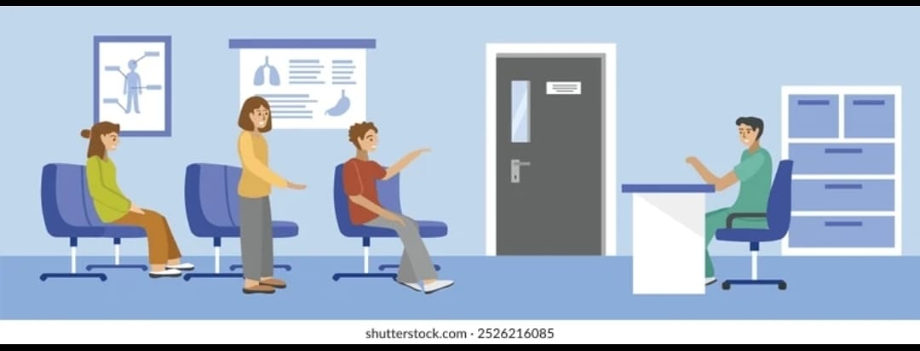
SAMPLE COLLECTION
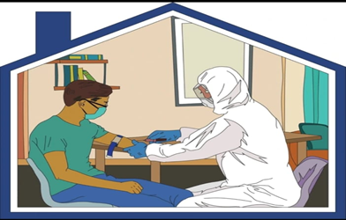
TRANSPORTING

Biochemistry
Hematology
Immunology
Serology

TESTING

REPORTING RESULT DESPATCH

HR MANAGEMENT
STAFF AVAILABILITY
- PSC STAFF-8NOS
- NHM STAFF-4NOS
- TEMPARORY STAFF-7NOS
WHEN MORE STAFF NEEDED
- REQUEST STAFF FROM PERIPHERY THROUGH DMO OFFICE
- REQUEST HELP FROM NEARBY PARAMEDICAL INSTITUTION
3.SAMPLE COLLECTION
During a pandemic, proper sample collection is critical to ensure accurate diagnosis while preventing transmission of infection to healthcare workers and the community. Strict biosafety measures must be followed at every stage of sample collection, handling, and transport.

1. Preparation and Planning
- Only trained personnel should collect samples.
- Collect samples in a designated, well-ventilated area.
- Ensure availability of Personal Protective Equipment (PPE) such as gloves, N95/FFP2 mask, face shield, gown, and shoe covers.
- Verify patient identity and explain the procedure to reduce anxiety and ensure cooperation.

2. Infection Control Measures
- Follow standard, contact, and droplet/airborne precautions as per the pathogen.
- Perform hand hygiene before and after sample collection.
- Use single-use, sterile collection materials.
- Avoid unnecessary contact with the patient and surroundings.
Training and Compliance
- Staff must receive regular training
- Adherence to national and WHO guidelines mandatory

4. Sample Collection Procedure
- Collect appropriate specimens depending on the disease (e.g., nasal/throat swab, blood, sputum).
- Ensure correct technique to avoid contamination and false results.
- Place specimens immediately into properly labelled, leak-proof containers.
- Disinfect the outer surface of the container after collection.
4.SAMPLE TRANSPORTATION
Tests not done in the lab such as culture and sensitivity sent to Public Health Lab and RT PCR are sent to NIV Lab Alappuzha

Purpose
To ensure safe, secure, and contamination-free transportation of clinical samples during a pandemic, protecting healthcare workers, laboratory staff, and the community.

Responsibilities
- Sample Collector: Proper labelling, packaging, and documentation
- Transport Personnel: Safe handling and timely delivery
- Laboratory Staff: Receiving, verification, and decontamination

Personal Protective Equipment (PPE)
All personnel involved must wear:
- Gloves
- Mask (N95 or surgical as per risk assessment)
- Face shield or goggles
- Gown or lab coat

Sample Packaging (Triple Packaging System)
  - Leak-proof, sealed specimen container
  - Properly labeled (patient ID, date, type of sample)
  - Leak-proof biohazard bag
  - Absorbent material included
  - Biohazard symbol displayed
  - Rigid, insulated transport box
  - Clearly marked: “BIOLOGICAL SUBSTANCE”
  - Temperature control (ice packs if required)

Documentation
- Sample referral form placed outside secondary container
- Chain-of-custody maintained
- Time of collection and receipt recorded
Spill Management
- Follow spill response protocol
- Use disinfectant immediately
- Report incident to laboratory supervisor
Ruturning the sample box
Sample boxes return by the person who transport the sample
WASTE DISPOSAL

Used PPE and packaging disposed of as biomedical waste
- Follow local biomedical waste management guidelines

REPORTING
Reports are collected by the Nodal officer through E mail or portal

ANNEXURE 4 : NEARBY PVT LABS

SL. NO | NAME OF LAB | OWNER NAME |  | PHONE NUMBER
1 | Aswathi Lab Clinical Laboratory | Padmakumari
2 | Sankar’s Metropolis | Dr. K Ramesh Kumar |  | 9447044923
3 | Julie Anns Laboratory and ECG Clinic | P O Thomas |  | 9446071869
4 | Medivision | BinuPonnuran
5 | NNS Hi Care Lab | Noushad |  | 9020099699
6 | Dial Scans | Dr. Louis Thomas |  | 9496185822
7 | S Path Lab and Scan Pvt Ltd | Dr. R Manikumar |  | 9495989943
8 | MRC Scan and Healthcare | Gurunadan | 9495989973
9 | Kochin Lab | Sheela Sajeev | 9846104086
10 | Health One Lab | Geena | 8943006920
11 | JJ Lab and ECG | Jaya Prakash | 9846100600
12 | BDRC Precision in Health Care | Subair | 9747353735
13 | Jana Seva Lab | Muhammed Rafi | 9444394834
14 | C and C Clinical Laboratory | Achamma Thomas | 7736806230
15 | B and B Lab | Binu K S | 9656846722
16 | Yes Vision Lab | Sabu Mohandas | 9037646355
17 | Vinayaka Lab | Binu | 866010001

ANNEXURE 5: PHARMACY BUFFER STOCK

ESSENTIAL DRUG LIST KMSCL
SLNO | ITEMCODE | ITEMNAME
1 | S27231/12 | ABSORBANT COTTON GAUZE SCH.F(II) ,100 cm X 20 mtr ,Packet
2 | S27007 | ABSORBANT COTTON WOOL IP ,500gm Net ,Packet
3 | D01019 | ACECLOFENAC TAB IP ,100 mg ,1 No
4 | D19006 | ACETAZOLAMIDE TAB IP ,250 mg ,1 No
5 | D13036 | ACETYL SALICYLIC ACID TAB IP(GASTRO-RESISTANT) ,150 mg ,1 No
6 | D13024 | ACETYLSALICYLIC ACID TAB IP(GASTRO-RESISTANT) ,75mg ,1 No
7 | D06002/12 | ACTIVATED CHARCOAL IP ,10gm ,Packet
8 | D15014 | ACYCLOVIR EYE OINTMENT IP ,3% w/w ,5gm Tube
9 | D09017 | ACYCLOVIR INTRAVENOUS INFUSION IP ,500 mg ,Vial
10 | D09004 | ACYCLOVIR ORAL SUSPENSION IP ,400 mg/5 ml ,100 ml Bottle
11 | D09002/12 | ACYCLOVIR TAB IP ,400 mg ,1 No
12 | D09005 | ACYCLOVIR TAB IP ,800 mg ,1 No
13 | D13037 | ADENOSINE INJ IP ,3 mg/ml ,10 ml
14 | D13062 | ADENOSINE INJ IP ,3mg/ml ,2ml amp
15 | S27002 | ADHESIVE TAPE USP ,10 cm X 5 mtr ,Roll
16 | D05005 | ADRENALINE BITARTRATE INJ IP ,1mg/ml ,1 ml Amp
17 | D08015 | ALBENDAZOLE ORAL SUSPENSION IP ,200 mg/5ml ,10 ml Bottle
18 | D08001 | ALBENDAZOLE TAB IP ,400 mg ,1 No
19 | D01013 | ALLOPURINOL TAB IP ,100 MG ,1 No
20 | D17007/12 | ALPRAZOLAM TAB IP ,0.25mg ,1 No
21 | D12030 | ALTEPLASE INJ ,50 mg ,Vial
22 | D02091 | AMIKACIN SULPHATE INJ IP ,250mg/2ml ,2ml Vial
23 | D03003 | AMINOPHYLLINE INJ IP ,25mg/ml ,10ml Amp
24 | D13040 | AMIODARONE STERILE CONCENTRATE IP ,50mg/ml ,3 ml
25 | D13041 | AMIODARONE TAB IP ,100mg ,1 No
26 | D17063 | AMISULPRIDE TAB IP ,100 mg ,1no
27 | D17005 | AMITRIPTYLINE TAB IP ,25mg ,1 No
28 | D13031/12 | AMLODIPINE TAB IP(FILM COATED) ,5 mg ,1 No
29 | D02036/12 | AMOXICILLIN AND POTASSIUM CLAVULANATE TAB IP ,500mg+125mg ,1 No
30 | D02092 | AMOXYCILLIN + POTASSIUM CLAVULANATE ORAL SUSPENSION ,Each ml of reconstituted suspension contains; Amoxycillin Trihydrate IP equivalent to Amoxicillin 80mg and Potassium Clavunate IP equivalent to Clavulanic Acid 11.4mg ,10 ml Bottle
31 | D02049 | AMOXYCILLIN AND POTASSIUM CLAVULANATE INJ IP ,1.2gm ,10 ml Vial
32 | D02197 | AMOXYCILLIN AND POTASSIUM CLAVULANATE ORAL SUSPENSION IP ,Each 5 ml contains; 400 mg + 57 mg ,60 ml Bottle
33 | D02005 | AMOXYCILLIN CAP IP ,500 mg ,1 No
34 | D02044 | AMOXYCILLIN DISPERSIBLE TAB IP ,250 mg ,1 No
35 | D02033 | AMOXYCILLIN ORAL SUSPENSION IP ,250mg/5ml ,60 ml bottle
36 | D08036 | AMPHOTERICIN B INJ IP ,50 mg/ml ,Vial
37 | D08018 | AMPHOTERICIN B LIPOSOMAL INJ ,50mg ,Vial
38 | D02196 | AMPICILLIN AND SULBACTAM FOR INJ ,Each vial contains Ampicillin 1g and Sulbactam 0.5g ,Vial
39 | D02007 | AMPICILLIN CAP IP ,250 mg ,1 No
40 | D02041 | AMPICILLIN CAP IP ,500mg ,1 No
41 | D02008 | AMPICILLIN INJ IP ,500 mg ,Vial
42 | D20105 | ANTACID SUSPENSION ,Each 5 ml contains Dried Aluminium Hydroxide Gel IP- 250 mg, Magnesium Hydroxide IP- 250 mg, Activated Dimethicone- 50 mg ,100 ml Bottle
43 | D26002 | ANTI A MONOCLONAL IgM TITRE VALUE 512 (MINIMUM) SOLUTION ,10ml ,Bottle
44 | D26003 | ANTI AB MONOCLONAL IgM TITRE VALUE 512 (MINIMUM)SOLUTION ,10 ML ,Bottle
45 | D26004 | ANTI B MONOCLONAL IgM TITRE VALUE 512 (MINIMUM) SOLUTION ,10ml ,Bottle
46 | D26005 | ANTI D MONOCLONAL IgM TITRE VALUE 512 SOLUTION ,10ML ,Bottle
47 | D26030 | ANTI HUMAN GLOBULIN SERUM (COOMBS SERUM) POLY SPECIFIC (IgG + C3d) ,5ml ,Vial
48 | D26011 | ANTI HUMAN SERUM (LISS COOMBS FOR GEL TECHNOLOGY - GEL CARD & SOLUTION) ,Null ,Bottle
49 | D21012 | ANTI SNAKE VENOM (FREEZE DRIED) POLYVALENT INJ ,10ml ,Vial
50 | D17064 | ARIPIPRAZOLE TAB IP ,10 mg ,1 no
51 | D08031 | ARTESUNATE +(SULPHADOXINE + PYREMETHAMINE) ,Each Combi Blister Pack contains; [3 tablets of Artesunate (each 200mg) and 2 tablets of Sulphadoxine + Pyremethamine (each 750mg + 37.5mg)] OR [3 tablets of Artesunate (each 200mg) and 3 tablets of Sulphadoxine + Pyremethamine (each 500mg + 25mg)] ,1 Blister Pack
52 | D08019 | ARTESUNATE INJ IP ,60mg ,Vial
53 | D17044 | ATOMOXETINE TAB ,10mg ,1 No
54 | D17045 | ATOMOXETINE TAB ,25mg ,1 No
55 | D13013 | ATORVASTATIN TAB IP ,10 mg ,1 No
56 | D13043 | ATORVASTATIN TAB IP ,20mg ,1 No
57 | D04023 | ATRACURIUM BESYLATE INJ IP ,10mg/ml ,2.5ml amp
58 | D15016 | ATROPINE EYE DROPS BP/USP ,1% ,5 ml bottle
59 | D15017 | ATROPINE EYE OINTMENT IP ,1%w/w ,5gm Tube
60 | D04007 | ATROPINE SULPHATE INJ IP ,0.6mg/ml ,1 ml Amp
61 | D06017 | ATROPINE SULPHATE INJ IP ,1mg/ml ,100ml
62 | D02052 | AZITHROMYCIN INJ ,500mg ,10 ml Vial
63 | D02093 | AZITHROMYCIN ORAL SUSPENSION IP ,200mg/5 ml ,30ml bottle
64 | D02031 | AZITHROMYCIN TAB IP ,500 mg ,1 No
65 | D02099 | AZTREONAM INJ USP ,1 gm ,Vial
66 | D01049 | BACLOFEN TAB IP ,10 MG ,1 no
67 | D23006 | BARIUM SULPHATE SUSPENSION BP/USP ,95% w/v ,500 ml Bottle
68 | D14026/12 | BENZYL BENZOATE APPLICATION IP ,25% w/w ,100 ml bottle
69 | D02009 | BENZYL PENCILLIN INJ IP ,10 lakhs units ,Vial
70 | D05017 | BETAHISTINE TAB IP ,8mg ,1 No
71 | D14046 | BETAMETHASONE DIPROPIONATE CREAM IP ,0.05% w/w ,10 gm Tube
72 | D05004 | BETAMETHASONE INJ IP ,4mg/ml ,1ml Amp
73 | D19015 | BETHANECHOL CHLORIDE TAB BP ,25 MG ,1 No
74 | D15019 | BIMATOPROST EYE DROPS ,0.03% ,3 ml
75 | D20038 | BISACODYL SUPPOSITORY IP ,5 mg ,1 No
76 | D20012 | BISACODYL TAB IP ,5mg ,1 No
77 | D25012 | BLACK DISINFECTANT FLUID (GRIII RWC 5-7) BIS LOTION ,5 Litre ,Can
78 | S27505 | BLACK SILK 5-0 1/2 CIRCLE ,TAPER CUT NEEDLE 17MM , 70- 90 CM ,1 Foil ,1 No
79 | S27009 | BLOOD ADMINISTRATION SET WITH MICROAGREGATE FILTER ,Ml ,1 No
80 | S27276 | BLOOD COLLECTION SINGLE BAG with CPDA1(49ml), 350ml bag with Diversion Pouch 20ml and Needle Protector(ISO 3826) ,350 ml ,1 No
81 | S27277 | BLOOD COLLECTION TRIPPLE BAG WITH SAGM , Diversion Pouch 20ml with needle protector. (ISO 3826) ,Sterile collapsible non-vented bags made up of DEHP plasticized PVC. Diversion Pouch 20ml. Primary bag - 350ml, with CPD (49ml). First Satelite bag - 300ml, Second Satelite bag - 300ml for platelet storage for 5 days. Slits on both sides of the bags. Flexible non-kinking transparent tubings. Needle - 16G straight sharp regular margins ultrathin walled and beveled tips with needle protector. ,1 No
82 | S27293 | BONE MARROW ASPIRATION NEEDLE ,16 G ,1 No
83 | D29008 | BOTULINUM TOXIN A INJ (FREEZE-DRIED POWDER FOR INJECTION) ,100 Units ,Vial
84 | D29009 | BOTULINUM TOXIN A INJ (FREEZE-DRIED POWDER FOR INJECTION) ,50 Units ,Vial
85 | S27014 | BP BLADE ,SIZE -10 ,1 NO
86 | S27015 | BP BLADE ,SIZE -11 ,1 NO
87 | S27016 | BP BLADE ,SIZE -15 ,1 NO
88 | S27017 | BP BLADE ,SIZE -20 ,1 NO
89 | S27019 | BP BLADE ,SIZE -22 ,1 NO
90 | S27508/12 | BRAIDED POLYGLYCOLIC ACID SUTURE 3-0, 40- 50CM, 3/8 CIRCLE CUTTING 12MM NEEDLE ,1 Foil ,1 No
91 | S27509 | BRAIDED POLYGLYCOLIC ACID SUTURE 5-0, 45CM, 3/8 CIRCLE REVERSE CUTTING 12MM NEEDLE ,1 Foil ,1 No
92 | S27510 | BRAIDED POLYGLYCOLIC ACID SUTURE 6-0, 45CM, 3/8 CIRCLE REVERSE CUTTING 12MM NEEDLE ,1 Foil ,1 No
93 | D15021 | BRIMONIDINE TARTRATE EYE DROPS IP ,0.20% w/v ,5 ml
94 | D05038 | BROMHEXINE TAB IP ,8 MG ,1 NO
95 | D03080 | BUDESONIDE INHALATION IP ,200 mcg/puff ,200 MD
96 | D03025 | BUDESONIDE NEBULISER SUSPENSION ,0.5mg/ml ,2ml respules
97 | D04017 | BUPIVACAINE HYDROCHLORIDE IN DEXTROSE INJ USP ,0.50% ,4 ml Amp
98 | D04030 | BUPIVACAINE INJ IP ,0.25% ,20 ml Vial
99 | D04031 | BUPIVACAINE INJ IP ,0.50% ,20 ml vial
100 | D25043 | Bleaching Powder (IS 1065) ,Minimum strength of available Chlorine is 32% ,1 kg Packet
101 | D03028 | CAFFEINE CITRATE INJ BP/USP ,20mg/ml ,3 ml Vial
102 | D03079 | CAFFEINE CITRATE ORAL SOLUTION IP ,20mg/ml (equivalent to 10mg of caffeine base) ,1.5 ml Vial
103 | D14030/12 | CALAMINE LOTION IP ,50 ml ,bottle
104 | D22062 | CALCITRIOL TAB ,0.25 MCG ,1 No
105 | D22061 | CALCIUM ACETATE TAB ,667 MG ,1 No
106 | D22059 | CALCIUM AND VITAMIN D3 TAB IP ,Equivalent to elemental calcium 500mg and Vitamin D3 250 IU ,1 No
107 | D22025 | CALCIUM CARBONATE +VITAMIN D3 SUSPENSION ,250mg + 125 IU ,100ml bottle
108 | D12029 | CALCIUM DOBESILATE CAP ,500mg ,1 No
109 | D22003 | CALCIUM GLUCONATE INJ IP ,10%w/v ,10ml
110 | D07024 | CARBAMAZEPINE ORAL SUSPENSION BP/USP ,100mg/5 ml ,30 ml bottle
111 | D07005 | CARBAMAZEPINE TAB IP ,200 mg ,1 No
112 | D11007 | CARBIDOPA + LEVODOPA TAB IP ,25mg+ 100mg ,1 No
113 | D21045 | CARBIMAZOLE TAB IP ,5 mg ,1 No
114 | D16002/12 | CARBOPROST TROMETHAMINE INJ IP ,250mcg/ml ,1ml Vial/Amp
115 | D15022 | CARBOXYMETHYLCELLULOSE EYE DROPS IP ,0.50% w/v ,10 ml
116 | D13045 | CARVEDILOL TAB IP ,6.25mg ,1 No
117 | D13070 | CARVEDILOL TAB IP ,25 mg ,1 No
118 | S27517 | CATGUT NO.1/0 RB 34-40 MM NEEDLE, 70-90 CM ,1 Foil ,1 No
119 | D02035 | CEFADROXIL TAB IP ,500 mg ,1 No
120 | D02094 | CEFAZOLIN SODIUM INJ IP ,1gm ,Vial
121 | D02113 | CEFIXIME ORAL SUSPENSION IP ,100 mg/5 ml ,30 ml Bottle
122 | D02055 | CEFIXIME TAB IP ,200mg ,1 No
123 | D02056 | CEFOPERAZONE + SULBACTAM INJ ,1gm+ 0.5gm ,Vial
124 | D02026 | CEFOTAXIME SODIUM INJ IP ,1gm ,Vial
125 | D02191 | CEFPODOXIME ORAL SUSPENSION IP ,100 mg/5 ml ,30 ml Bottle
126 | D02057 | CEFPODOXIME PROXETIL TAB IP ,200mg ,1 No
127 | D02195 | CEFTAZIDIME AND AVIBACTAM INJ ,Each vial contains Ceftazidime pentahydrate equivalent to Ceftazidime 2g and Avibactam sodium equivalent to avibactam 0.5g ,Vial
128 | D02100 | CEFTAZIDIME FOR INJ IP ,1 gm ,Vial
129 | D02034 | CEFTRIAXONE INJ IP ,1gm ,Vial
130 | D02095 | CEFUROXIME AXETIL ORAL SUSPENSION BP/USP ,125mg/5ml ,30ml bottle
131 | D02059 | CEFUROXIME AXETIL TAB IP ,500 mg ,1 No
132 | D02020 | CEFUROXIME INJ IP ,750 mg ,Vial
133 | D02101 | CEPHALEXIN CAP IP ,500 mg ,1 No
134 | D02112 | CEPHALEXIN ORAL SUSPENSION (DRY) IP ,125 mg/5ml ,60 ml Bottle
135 | D05018 | CETIRIZINE SYRUP IP ,5mg/ 5ml ,30 ml Bottle
136 | D05010 | CETIRIZINE TAB IP ,10 mg ,1 No
137 | D25010 | CHLORHEXIDINE GLUCONATE 2.5% V/V + ETHYL ALCOHOL 70% V/V SOLUTION ,200 ml ,Bottle
138 | D14022 | CHLORHEXIDINE MOUTH WASH IP ,0.2%w/v ,60ml bottle
139 | D25005 | CHLOROXYLENOL SOLUTION IP ,5% w/v ,1 Litre Bottle
140 | D05008 | CHLORPHENIRAMINE MALEATE INJ IP ,10 mg/ml ,1 ml Amp
141 | D05019 | CHLORPHENIRAMINE MALEATE TAB IP ,4mg ,1 No
142 | D17002 | CHLORPROMAZINE TAB IP ,50mg ,1 No
143 | D13071 | CHLORTHALIDONE TAB IP ,12.5 MG ,1 NO
144 | D13072 | CILNIDIPINE TAB IP ,10 mg ,1 No
145 | D13073 | CILOSTAZOL TAB IP ,50 mg ,1 NO
146 | D17035 | CINNARIZINE TAB IP ,25 mg ,1 No
147 | D15024 | CIPROFLOXACIN + DEXAMETHASONE EYE/EAR DROPS ,0.3 %+ 0.1 % ,10 ml
148 | D02063 | CIPROFLOXACIN + TINIDAZOLE TAB ,500mg + 600mg ,1 No
149 | D15002 | CIPROFLOXACIN EYE DROPS IP ,0.3% w/v ,5ml Bottle
150 | D02012 | CIPROFLOXACIN INJ IP ,2 mg/ml ,100ml Bottle
151 | D02011 | CIPROFLOXACIN TAB IP ,500 mg ,1 No
152 | D29010 | CITICOLINE INJ IP ,500 mg ,Amp
153 | D02065 | CLARITHROMYCIN TAB IP ,500mg ,1 No
154 | D02098 | CLINDAMYCIN + CLOTRIMAZOLE VAGINAL PESSARY ,100mg+200mg ,1 No
155 | D02087 | CLINDAMYCIN CAP IP ,300 mg ,1 No
156 | D02102 | CLINDAMYCIN GEL ,1% ,15 gm
157 | D07009 | CLOBAZAM TAB IP ,5 mg ,1 No
158 | D07033 | CLOBAZAM TAB IP ,10 MG ,1 No
159 | D14060 | CLOBETASOL PROPIONATE + SALICYLIC ACID OINTMENT ,0.05% w/w + 3% w/w ,20 gm Tube
160 | D14031 | CLOBETASOLE PROPIONATE CREAM IP ,0.05% w/w ,15gm Tube
161 | D16009 | CLOMIPHENE CITRATE TAB IP ,50mg ,1 No
162 | D17061 | CLOMIPRAMINE CAP IP ,25mg ,1 No
163 | D17076 | CLOMIPRAMINE TAB ,75 mg ,1 No
164 | D17038 | CLONAZEPAM TAB IP ,0.5 mg ,1 No
165 | D13046 | CLONIDINE TAB IP ,100mcg ,1 No
166 | D13068 | CLOPIDOGREL + ASPIRIN TAB IP ,75mg + 75mg ,1 no
167 | D13023 | CLOPIDOGREL TAB IP ,75 MG ,1 No
168 | D08039 | CLOTRIMAZOLE CREAM IP ,1% w/w ,10gm Tube
169 | D08021 | CLOTRIMAZOLE MOUTH PAINT ,1% ,15 ml
170 | D08008 | CLOTRIMAZOLE VAGINAL PESSARIES IP ,200 mg ,1 No
171 | D02006 | CLOXACILLIN CAP IP ,250 mg ,1 No
172 | D02029 | CLOXACILLIN INJ IP ,500MG ,IM/IV VIAL
173 | D17014 | CLOZAPINE TAB IP ,25MG ,1 No
174 | D17015 | CLOZAPINE TAB IP ,100mg ,1 No
175 | D02002 | CO-TRIMOXAZOLE ORAL SUSPENSION IP ,40mg+200mg ,50 ml Bottle
176 | D02001 | CO-TRIMOXAZOLE TAB IP ,160mg+ 800mg ,1 No
177 | D02103 | COLISTIMETHATE INJ IP ,3 miu ,Vial
178 | D03082 | COUGH SYRUP ,Each 5 ml contains: Ambroxol HCL- 15 mg, Guiphenesin- 50 mg , Terbutaline Sulphate- 1.25 mg , Menthol- 2.5 mg, Flavoured syrupy base q.s ,100 ml Bottle
179 | D32000 | CYCLOSPORINE CAP IP ,100 mg ,1 no
180 | D06018 | D-PENICILLAMINE CAP USP ,250 mg ,1 no
181 | D13074 | DABIGATRAN CAP ,110 mg ,1 No
182 | D21089 | DAPAGLIFLOZIN TAB ,10 mg ,1 No
183 | D10001 | DAPSONE TAB IP ,100 mg ,1 no
184 | D21046 | DARIFENACIN TAB ,7.5 mg ,1 NO
185 | D05021 | DEFLAZACORT TAB ,6mg ,1 No
186 | D26014 | DENGUE IgM CAPTURE ELISA (1,2,3,4) KIT ,1 TEST ,1 No
187 | D26026 | DENGUE LATEX AGGLUTINATION TEST KIT(RAPID METHOD) ,1 TEST ,1 No
188 | D06022 | DESFERRIOXAMINE INJ IP ,500 mg ,Vial
189 | D14048 | DESONIDE LOTION ,0.05% ,30 ml bottle
190 | D05001 | DEXAMETHASONE INJ IP ,4 mg/ml ,2 ml Vial
191 | D15069 | DEXAMETHASONE EYE DROPS BP ,0.10% ,5 ml
192 | D05003 | DEXAMETHASONE TAB IP ,0.5 mg ,1 No
193 | D04024 | DEXMEDETOMIDINE INJ USP ,200 mcg/2ml ,2 ml amp
194 | D12007 | DEXTRAN 40 IN SODIUM CHLORIDE INJ IP ,Low Molecular Wt Dextran 10% in Sodium Chloride Inj 0.9% ,500ml Bottle
195 | D18003 | DEXTROSE INJ IP ,5% ,500 ml Bottle
196 | D18004 | DEXTROSE INJ IP ,10% ,500 ml Bottle
197 | D18006 | DEXTROSE INJ IP ,25% ,100 ml Bottle
198 | D07007 | DIAZEPAM INJ IP ,5 mg/ml ,2ml Amp.
199 | D07026 | DIAZEPAM SUPPOSITORY ,5mg ,1 No
200 | D17001 | DIAZEPAM TAB IP ,5mg ,1 No
201 | D01028 | DICLOFENAC GEL IP ,1% w/w ,25gm Tube
202 | D01005 | DICLOFENAC SODIUM INJ IP ,25 mg/ml ,3 ml amp
203 | D01004 | DICLOFENAC SODIUM TAB IP(GASTRO-RESISTANT) ,50 mg. ,1 No
204 | D12033 | DICUMAROL TAB ,25mg ,1 No
205 | D20009 | DICYCLOMINE HCL INJ IP ,10mg/ml ,2ml Amp
206 | D20008 | DICYCLOMINE HCL TAB IP ,10 mg ,1 No
207 | D08003 | DIETHYL CARBAMAZINE TAB IP ,100 mg ,1 No
208 | D13015 | DIGOXIN INJ IP ,0.5mg/2 ml ,2 ml
209 | D13075 | DIGOXIN PAEDIATRIC SOLUTION IP ,50mcg/ml ,60 ml bottle
210 | D13014 | DIGOXIN TAB IP ,0.25 mg ,1 No
211 | D13076 | DILTIAZEM INJ IP ,5mg/ml ,5ml Vial
212 | D13004 | DILTIAZEM TAB IP ,30 mg ,1 No
213 | D21079 | DIPHTHERIA ANTITOXIN INJ IP ,1000 IU/ml ,10 ml Vial
214 | D22014 | DISODIUM HYDROGEN CITRATE SYRUP ,1.53 gm/5 ml ,100 ml Bottle
215 | S27255 | DISPOSABLE CVP CATHETER TRIPLE LUMEN (SELDINGER TECHNIQUE) ,5F ,1 No
216 | S27256 | DISPOSABLE CVP CATHETER TRIPLE LUMEN (SELDINGER TECHNIQUE) ,7F ,1 No
217 | S27025 | DISPOSABLE NEEDLE ,18 G ,1 No
218 | S27028 | DISPOSABLE NEEDLE ,22G x 1" ,1 No
219 | S27029 | DISPOSABLE NEEDLE ,23G x 1" ,1 No
220 | S27030 | DISPOSABLE NEEDLE ,24G x 1" ,1 No
221 | S27254 | DISPOSABLE NEEDLE ,26G x ?" ,1 No
222 | S27099 | DISPOSABLE SURGEONS CAP - FEMALE ,1 Unit ,1 No
223 | S27098 | DISPOSABLE SURGEONS CAP - MALE ,1 Unit ,1 No
224 | S27241 | DISPOSABLE SYRINGE WITH FIXED NEEDLE 29 G (1ML GRADUATED) ,40 IU ,1 No
225 | S27242 | DISPOSABLE SYRINGE WITH FIXED NEEDLE 29 G (1ML GRADUATED) ,100 IU ,1 No
226 | S27031 | DISPOSABLE SYRINGE WITHOUT NEEDLE (ISO 7886) ,2 Cc ,1 No
227 | S27032 | DISPOSABLE SYRINGE WITHOUT NEEDLE (ISO 7886) ,5 Cc ,1 No
228 | S27033 | DISPOSABLE SYRINGE WITHOUT NEEDLE (ISO 7886) ,10 Cc ,1 No
229 | S27218 | DISPOSABLE SYRINGE WITHOUT NEEDLE(ISO 7886) ,20 Cc ,1 No
230 | S27039 | DISPOSABLE THREE WAY STOPCOCK ,1 Unit ,1 No
231 | S27275 | DISPOSABLE TRIPLE LAYER MASK WITH TYING STRAP IS 16289:2014 ,1 UNIT ,1NO
232 | D07028 | DIVALPROEX SODIUM PROLONGED RELEASE TAB IP ,500mg ,1 no
233 | D13017 | DOBUTAMINE HCL INJ IP ,50 mg/ml ,5 ml Amp/vial
234 | D20072 | DOMPERIDONE SUSPENSION IP ,5 mg/5 ml ,30 ml Bottle
235 | D20007/12 | DOMPERIDONE TAB IP (FILM COATED) ,10 mg ,1 No
236 | D17062 | DONEPEZIL TAB IP ,10mg ,1 No
237 | D13016 | DOPAMINE HCL INJ IP/USP ,40 mg/ml ,5 ml
238 | D15027 | DORZOLAMIDE + TIMOLOL EYE DROPS IP ,2% w/v + 0.5% w/v ,5 ml
239 | D15028 | DORZOLAMIDE EYE DROPS IP ,2% w/v ,5 ml
240 | D02105 | DOXYCYCLINE INJ ,100 MG ,Vial
241 | D02014/12 | DOXYCYCLINE TAB USP ,100 mg ,1 No
242 | D20027 | DOXYLAMINE SUCCINATE TAB USP ,10mg ,1 No
243 | D21047 | DUTASTERIDE CAP IP ,0.5 mg ,1 no
244 | D16027 | DYDROGESTERONE TAB IP ,10 MG ,1 NO
245 | S27219 | ECG ELECTRODES ,Null ,1 No
246 | S27194 | ECG GEL ,250 GM ,BOTTLE
247 | D13032/12 | ENALAPRIL MALEATE TAB IP(FILM COATED) ,5 mg ,1 No
248 | S27045 | ENDOTRACHEAL TUBE 2.5 ,1 Unit ,1 No
249 | S27046 | ENDOTRACHEAL TUBE 3.0 ,1 Unit ,1 No
250 | S27047 | ENDOTRACHEAL TUBE 3.5 ,1 Unit ,1 No
251 | S27048 | ENDOTRACHEAL TUBE 4.0 ,1 Unit ,1 No
252 | S27049 | ENDOTRACHEAL TUBE 4.5 ,1 Unit ,1 No
253 | S27050 | ENDOTRACHEAL TUBE 5.0 ,1 Unit ,1 No
254 | S27051 | ENDOTRACHEAL TUBE 5.5 ,1 Unit ,1 No
255 | S27054 | ENDOTRACHEAL TUBE 5.5 WITH CUFF ,1 Unit ,1 No
256 | S27052 | ENDOTRACHEAL TUBE 6.0 ,1 Unit ,1 No
257 | S27055 | ENDOTRACHEAL TUBE 6.0 WITH CUFF ,1 Unit ,1 No
258 | S27053 | ENDOTRACHEAL TUBE 6.5 ,1 Unit ,1 No
259 | S27056 | ENDOTRACHEAL TUBE 6.5 WITH CUFF ,1 Unit ,1 No
260 | S27057 | ENDOTRACHEAL TUBE 7.0 WITH CUFF ,1 Unit ,1 No
261 | S27058 | ENDOTRACHEAL TUBE 7.5 WITH CUFF ,1 Unit ,1 No
262 | S27059 | ENDOTRACHEAL TUBE 8.0 WITH CUFF ,1 Unit ,1 No
263 | S27060 | ENDOTRACHEAL TUBE 8.5 WITH CUFF ,1 Unit ,1 No
264 | S27061 | ENDOTRACHEAL TUBE 9.0 WITH CUFF ,1 Unit ,1 No
265 | D12060 | ENOXAPARIN INJECTION IP (LOW MOLECULAR WEIGHT HEPARIN INJ) ,40 mg/0.4 ml ,Amp
266 | D09008 | ENTECAVIR TAB IP ,0.5 MG ,1 NO
267 | S27222 | EPIDURAL SET WITH LOR SYRINGE & FILTER ,18G ,1 No
268 | D21015 | EQUINE ANTI RABIES IMMUNOGLOBULIN INJ ,300 IU/ml ,5 ml Vial
269 | D12022 | ERYTHROPOETIN RECOMBINANT INJ ,4000 IU ,Vial/PFS
270 | D17029 | ESCITALOPRAM TAB IP ,10 mg ,1 No
271 | D13077 | ESMOLOL INJ IP ,10 mg/ml ,10 ml
272 | D12034 | ETHAMSYLATE INJ ,125mg/ml ,2 ml
273 | D16028 | ETHINYL OESTRADIOL AND CYPROTERONE ACETATE TAB ,35 mcg+ 2mg ,1 no
274 | D04032 | ETOMIDATE INJ USP ,2 mg/ml ,10 ml
275 | S27279 | Examination Gloves Rubber (Powder free) ,Large ,1 No
276 | S27280 | Examination Gloves Rubber (Powder free) ,Medium ,1 No
277 | D21048 | FEBUXOSTAT TAB ,40 mg ,1 no
278 | D01023 | FENTANYL CITRATE INJ IP ,50mcg/ml ,2 ml Amp
279 | D22006 | FERROUS SULPHATE TAB IP ,Each tablet contains Dried Ferrous Sulphate 200mg equivalent to elemental iron 60mg ,1 No
280 | D05022 | FEXOFENADINE TAB IP ,120mg ,1 No
281 | D21049 | FINASTERIDE TAB IP ,5 MG ,1 NO
282 | S27291 | FISTULA NEEDLE ,16G ,1 No
283 | S27292 | FISTULA NEEDLE ,17G ,1 No
284 | D19014 | FLAVOXATE TAB IP ,200 MG ,1 No
285 | D08023 | FLUCONAZOLE INFUSION BP ,200mg/100 ml ,100 ml bottle
286 | D08014 | FLUCONAZOLE TAB IP ,150 MG ,1 No
287 | D05037 | FLUNARIZINE TAB IP ,10mg ,1 No
288 | D15029 | FLUOROMETHOLONE EYE DROPS IP ,0.10% w/v ,5 ml
289 | D17008 | FLUOXETINE CAP IP ,10mg ,1 No
290 | D17036 | FLUOXETINE CAP IP ,20 mg ,1 No
291 | D17066 | FLUPENTHIXOL INJ IP ,20 mg/ml ,Amp
292 | D17013 | FLUPHENAZINE DECANOATE INJ IP ,25MG ,1ML Amp
293 | D15030 | FLURBIPROFEN EYE DROPS IP ,0.03% w/v ,5 ml
294 | D14049 | FLUTICASONE CREAM IP ,0.05% W/W ,15 gm
295 | D03030 | FLUTICASONE FUROATE NASAL SPRAY ,27.5 mcg ,120 MD
296 | D17067 | FLUVOXAMINE TAB IP ,100 mg ,1 NO
297 | D12002 | FOLIC ACID TAB IP ,5 mg ,1 No
298 | S27062 | FOLLEYS CATHETER ,SIZE 12F X 10 ML ,1 No
299 | S27063 | FOLLEYS CATHETER ,SIZE 16F X 30 ML ,1 No
300 | S27064 | FOLLEYS CATHETER ,SIZE 18F X 30 ML ,1 No
301 | S27067 | FOLLEYS CATHETER ,SIZE 10F X 10 ML ,1 No
302 | S27193 | FOLLEYS CATHETER ,SIZE 14F X 30 ML ,1 No
303 | D25014 | FORMALDEHYDE SOLUTION IP ,37% w/v ,450 ml Bottle
304 | D03058 | FORMOTEROL FUMARATE AND BUDESONIDE INHALER ,6 MCG +200 MCG ,120 MD
305 | D07029 | FOSPHENYTOIN INJ ,Each ml contains; Fosphenytoin Sodium 75mg equivalent to Phenytoin Sodium 50mg ,2ml Vial
306 | D26024 | FOURTH GENERATION ELISA KIT FOR DETECTION OF P24 ANTIGEN AND ANTIBODY TO HIV 1&2 ,1 TEST ,1 No
307 | D14012 | FRAMYCETIN SKIN CREAM ,1% w/w ,30 gm Tube
308 | D19002 | FRUSEMIDE INJ IP ,10mg/ml ,2ml Amp
309 | D19001 | FRUSEMIDE TAB IP ,40mg ,1 No
310 | D19016 | FUROSEMIDE ORAL SOLUTION ,10 mg/ml ,30 ml Bottle
311 | D07016 | GABAPENTIN TAB IP ,100mg ,1 No
312 | D23013 | GADOBENATE DIMEGLUMINE INJ ,529 mg/ml ,10 ml Vial
313 | D14033 | GENTAMICIN + CLOTRIMAZOLE + BECLOMETHASONE CREAM ,0.1% + 1% + 0.025% ,5 gm Tube
314 | D15032 | GENTAMICIN EYE DROPS IP ,0.3% W/V ,5 ml
315 | D02013 | GENTAMICIN INJ IP ,40 mg/ml ,IM/IV 2ml VIAL
316 | D21078 | GLICLAZIDE TAB ,40 MG ,1 NO
317 | D21028 | GLIMEPIRIDE TAB IP ,1 mg ,1 No
318 | D21032/12 | GLIMEPIRIDE TAB IP ,2mg ,1 No
319 | S27196 | GLOVES SURGICAL RUBBER -STERILE (IS 13422) ,SIZE 6" ,Pair
320 | S27197 | GLOVES SURGICAL RUBBER -STERILE (IS 13422) ,SIZE 6.5" ,Pair
321 | S27198 | GLOVES SURGICAL RUBBER -STERILE (IS 13422) ,SIZE 7" ,Pair
322 | S27199 | GLOVES SURGICAL RUBBER -STERILE (IS 13422) ,SIZE 7.5" ,Pair
323 | D25007 | GLUTERALDEHYDE SOLUTION(WITHOUT SURFACTANT) ,2% ,5 Litre Can
324 | D20104 | GLYCERINE AND SODIUM CHLORIDE ENEMA ,Contains: Glycerine IP 15% w/v, Sodium Chloride IP 15% w/v and Purified Water IP q.s ,100 ml
325 | D04019 | GLYCOPYRROLATE INJ IP ,0.2mg/ml ,1ml Amp
326 | D17012 | HALOPERIDOL INJ IP ,5mg/ml ,1ml Amp
327 | D17010 | HALOPERIDOL TAB IP ,5 mg ,1 No
328 | D17052 | HALOPERIDOL TAB IP ,1.5 mg ,1 No
329 | D16029 | HCG (HUMAN CHORIONIC GONADOTROPIN) INJ IP ,5000 IU ,Vial
330 | D12003 | HEPARIN SODIUM INJ IP ,5000 IU/ml ,5 ml Vial
331 | D21090 | HEPATITIS B VACCINE (rDNA) IP ,20 mcg ,1ml Amp
332 | D26023 | HEPATITIS B SURFACE ANTIGEN SCREENING KIT-EIA VISUAL ASSAY TEST ,1 TEST ,1 No
333 | D26022 | HEPATITIS B SURFACE ANTIGEN SCREENING-ELISA TEST KIT ,1 TEST ,1 No
334 | D26016 | HEPATITIS C ANTIBODY SCREENING KIT - EIA VISUAL ASSAY(RAPID METHOD) ,1 TEST ,1 No
335 | D26034 | HEPATITIS C- ELISA KIT FOR DETECTION OF ANTIGEN AND ANTIBODY - FOURTH GENERATION ,1 TEST ,1 No
336 | D26019 | HIV 1&2 ANTIBODY SCREENING EIA VISUAL ASSAY (RAPID METHOD) ,1 TEST ,1 No
337 | D26018 | HIV 1&2 ANTIBODY SCREENING-ELISA TEST KIT ,1 TEST ,1 No
338 | D15034 | HOMATROPINE EYE DROPS IP ,2% w/v ,5 ml
339 | D12018 | HUMAN ALBUMIN INJ IP ,20% ,100 ml
340 | D21085 | HUMAN NORMAL IMMUNOGLOBULIN FOR INTRAVENOUS USE IP ,5 gm ,100 ml
341 | D04025 | HYALURONIDASE INJ IP ,1500 U ,1 ml Vial
342 | D19005 | HYDROCHLOROTHIAZIDE TAB IP ,25 mg ,1 No
343 | D05040 | HYDROCORTISONE CREAM IP ,1% ,15 gm
344 | D05002 | HYDROCORTISONE SODIUM SUCCINATE INJ IP ,100 mg ,Vial
345 | D25039 | HYDROGEN PEROXIDE SOLUTION IP ,20 Vol ,100 ml Bottle
346 | D08024 | HYDROXY CHLOROQUINE TAB IP ,200mg ,1 No
347 | D12006 | HYDROXY ETHYL STARCH IV INFUSION 6% ,130kDa/0.4 ,500 ml Bottle
348 | D16013 | HYDROXY PROGESTERONE CAPROATE INJ IP ,250mg/ ml ,1 ml Amp
349 | D16024 | HYDROXY PROGESTERONE CAPROATE INJ IP ,250mg/ml ,2 ml Amp
350 | D15035 | HYDROXY PROPYL METHYL CELLULOSE EYE DROPS ,0.3% ,10 ml
351 | D24108C | HYDROXY UREA CAP IP ,500mg ,1 No
352 | D15036 | HYDROXYPROPYL METHYL CELLULOSE OPHTHALMIC SOLUTION ,2% ,2 ml [PFS]
353 | D05024 | HYDROXYZINE TAB IP ,25mg ,1 No
354 | D20028 | HYOSCINE BUTYLBROMIDE INJ IP ,20mg/ml ,1 ml amp
355 | S27038 | I.V. CANNULA ,24G ,1 No
356 | S27034 | I.V. CANNULA WITH INJECTION PORT ,16G ,1 No
357 | S27035 | I.V. CANNULA WITH INJECTION PORT ,18G ,1 No
358 | S27036 | I.V. CANNULA WITH INJECTION PORT ,20G ,1 No
359 | S27037 | I.V. CANNULA WITH INJECTION PORT ,22G ,1 No
360 | S27246 | I.V. SET WITH 22G NEEDLE (ISO 8536) ,1 Unit ,1 No
361 | D01031 | INDOMETHACIN CAP IP ,25mg ,1 No
362 | S27069 | INFANT FEEDING TUBE ,SIZE 4F ,1 No
363 | S27070 | INFANT FEEDING TUBE ,SIZE 10F ,1 No
364 | S27071 | INFANT FEEDING TUBE ,SIZE 5F ,1 No
365 | S27072 | INFANT FEEDING TUBE ,SIZE 6F ,1 No
366 | S27073 | INFANT FEEDING TUBE ,SIZE 8F ,1 No
367 | D21031 | INSULIN INJECTION BIPHASIC ISOPHANE IP 30:70 (30% soluble insulin and 70% isophane insulin) ,40 IU/ml ,10 ml Vial
368 | D21006 | INSULIN INJECTION ISOPHANE IP ,40 IU/ml ,10 ml Vial
369 | D21005 | INSULIN INJECTION SOLUBLE IP ,40 IU /ml ,10 ml Vial
370 | D23001 | IOHEXOL INJ USP ,350mg/ml ,50ml
371 | D23007 | IOHEXOL INJ USP ,350mg/ml ,100 ML BOTTLE
372 | D03013 | IPRATROPIUM NEBULISING SOLUTION ,250mcg/ml ,15 ml
373 | D22016 | IRON SUCROSE INJ USP ,20mg elemental Iron/ml ,5ml AMP
374 | D04022 | ISOFLURANE LIQUID ,100ml ,Bottle
375 | D13080 | ISOPRENALINE INJ IP ,2mg/ml ,1 ml
376 | D13002 | ISOSORBIDE DINITRATE TAB IP ,10 mg ,1 No
377 | D08040 | ITRACONAZOLE TAB ,200 mg ,1 NO
378 | D13081 | IVABRADINE TAB ,5 mg ,1 NO
379 | D08026 | IVERMECTIN TAB IP ,6mg ,1 No
380 | D04001 | KETAMINE INJ IP ,50 mg/ml ,10 ml Vial
381 | D08030 | KETOCONAZOLE CREAM BP ,2% ,5gm Tube
382 | D01051 | KETOROLAC TROMETHAMINE INJ IP ,30 mg/ml ,1 ml amp
383 | D21050 | L ORNITHINE L ASPARTATE INFUSION ,5 gm/10ml ,Amp
384 | D13063 | LABETALOL INJ IP ,5mg/ml ,4ml Amp
385 | D13051 | LABETALOL TAB IP ,100mg ,1 No
386 | D07043 | LACOSAMIDE TAB ,100 mg ,1 No
387 | D20043 | LACTULOSE ENEMA ,20% w/v ,275 ml
388 | D20015 | LACTULOSE SOLUTION IP ,667 mg/ ml ,100 ml
389 | D09009 | LAMIVUDINE TAB IP ,100 MG ,1 NO
390 | D07027 | LEVETIRACETAM INJ ,100mg/ml ,Amp/Vial
391 | D07017 | LEVETIRACETAM ORAL SOLUTION IP ,100mg/ml ,30 ml bottle
392 | D07018 | LEVETIRACETAM TAB IP ,500mg ,1 No
393 | D05027 | LEVOCETIRIZINE TAB IP ,5mg ,1 No
394 | D02106 | LEVOFLOXACIN INFUSION IP ,500 mg ,100 ML BOTTLE
395 | D02075 | LEVOFLOXACIN TAB IP ,500mg ,1 No
396 | D04027 | LIGNOCAINE + PRILOCAINE CREAM IP ,2.5% + 2.5% ,5 gm Tube
397 | D04018 | LIGNOCAINE 2% WITH ADRENALINE INJ IP ,1:200000 ,30 ml
398 | D04003 | LIGNOCAINE HCL GEL IP ,2% w/v ,30 gm Tube.
399 | D04061 | LIGNOCAINE HCL INJ IP ,4 % W/V ,30 ml vial
400 | D04038 | LIGNOCAINE HCL INJ IP (FOR IM USE) ,2% w/v ,10 ml Vial
401 | D04029 | LIGNOCAINE HCL INJ IP (FOR IV USE - PRESERVATIVE FREE) ,2% w/v ,30 ml Vial
402 | D04036 | LIGNOCAINE HYDROCHLORIDE TOPICAL SOLUTION IP ,2% w/v ,100 ML BOTTLE
403 | D04035 | LIGNOCAINE SPRAY ,10% ,50 ml BOTTLE
404 | D02079 | LINEZOLID FOR ORAL SUSPENSION ,100 mg/5 ml ,30 ml Bottle
405 | D02076 | LINEZOLID INJ ,200mg/100 ml ,300 ml bottle
406 | D02078 | LINEZOLID TAB IP ,600mg ,1 No
407 | D14024 | LIQUID PARAFFIN IP ,100 ml ,BOTTLE
408 | D17025 | LITHIUM CARBONATE TAB IP ,300 mg ,1 No
409 | D17034 | LORAZEPAM INJ IP ,2 mg/ml ,2 ml Amp
410 | D17033 | LORAZEPAM TAB IP ,2 mg ,1 No
411 | D13011 | LOSARTAN POTASSIUM TAB IP ,25 mg ,1 No
412 | D13053 | LOSARTAN POTASSIUM TAB IP ,50mg ,1 No
413 | D16007 | MAGNESIUM SULPHATE INJ IP ,500mg/ml ,2ml Amp
414 | D14042 | MAGNESIUM SULPHATE PASTE BP ,100gm ,Bottle
415 | D26006 | MALARIA ANTIGEN DETECTING CARD (PV+PF) ,1 TEST ,1 No
416 | D18010 | MANNITOL INJ IP ,20%w/v ,100 ml Bottle
417 | D22031 | MECOBALAMINE TAB ,500mcg ,1 NO
418 | D16015 | MEDROXY PROGESTERONE ACETATE DEPOT INJ ,150 mg/ml ,Amp/Vial
419 | D16016 | MEDROXY PROGESTERONE ACETATE TAB IP ,10mg ,1 No
420 | D01100 | MEFENAMIC ACID SUSPENSION IP ,100 mg/5 ml ,60 ml Bottle
421 | D01014 | MEFENAMIC ACID TAB BP ,500 mg ,1 No
422 | D16030 | MENOTROPIN FOR INJECTION (HMG -HUMAN MENOPAUSAL GONADOTROPIN) IP/BP ,75 IU ,Vial
423 | D12035 | MEPHENTERMINE INJ IP ,30 MG/ml ,10 ML vial
424 | D02096 | MEROPENEM INJ IP ,1gm ,Vial
425 | D21076 | METFORMIN HCL SUSTAINED RELEASE TAB IP ,500 mg ,1 No
426 | D21065 | METFORMIN HYDROCHLORIDE SUSTAINED RELEASE TAB IP ,1 GM ,1 No
427 | D05028 | METHYL PREDNISOLONE SODIUM SUCCINATE INJ USP ,1 gm ,Vial
428 | D12068 | METHYLENE BLUE INJ ,10 mg/ml ,Amp
429 | D16004 | METHYLERGOMETRIN MALEATE INJ IP ,200mcg/ ml ,1ml Amp
430 | D17054 | METHYLPHENIDATE TAB ,10mg ,1 No
431 | D05041 | METHYLPREDNISOLONE TAB IP ,8 mg ,1 no
432 | D20005 | METOCLOPRAMIDE INJ IP ,5 mg/ml ,2 ml Amp
433 | D20006 | METOCLOPRAMIDE TAB IP ,10 mg ,1 No
434 | D13083 | METOPROLOL INJ IP ,1mg/ml ,5ml Amp
435 | D13131 | METOPROLOL SUCCINATE PROLONGED RELEASE TAB IP ,50 MG ,1 No
436 | D02097 | METRONIDAZOLE BENZOATE ORAL SUSPENSION IP ,200mg/5 ml ,30ml bottle
437 | D02086 | METRONIDAZOLE GEL IP ,1% w/w ,25 gm Tube
438 | D02025 | METRONIDAZOLE INJ IP ,5 mg/ml ,100ml bottle
439 | D02024 | METRONIDAZOLE TAB IP ,400 mg ,1 No
440 | D14041 | MICONAZOLE CREAM IP ,2% w/w ,10gm Tube
441 | D07011 | MIDAZOLAM INJ IP ,1 mg/ml ,5 ml Vial
442 | D16017 | MIFEPRISTONE TAB IP ,200mg ,1 No
443 | D17030 | MIRTAZAPINE TAB IP ,15 mg ,1 No
444 | D16026 | MISOPROSTOL TAB IP ,200mcg ,1 No
445 | D16033 | MISOPROSTOL TAB IP ,100 mcg ,1 NO
446 | D16034 | MISOPROSTOL TAB IP ,25 mcg ,1 no
447 | D14051 | MOMETASONE FUROATE CREAM IP ,0.1% w/w ,10 gm Tube
448 | S27575 | MONOFILAMENT BLACK POLYAMIDE 8-0, 3/8 CIRCLE REVERSE CUTTING MICRO POINT SPATULATED 8MM, 30-40CM ,1 Foil ,1 No
449 | S27576 | MONOFILAMENT BLUE POLYPROPYLENE 6-0, 3/8 CIRCLE TAPER CUT, DOUBLE ARMED ,13MM,70-90 CM ,1 Foil ,1 No
450 | S27577 | MONOFILAMENT POLYAMIDE 10-0, 1/2 CIRCLE MICROPOINT SPATULATED DOUBLE NEEDLE 6MM-30-40 CM ,1 Foil ,1 No
451 | S27520/12 | MONOFILAMENT POLYAMIDE 2-0,30-36MM, 3/8 CIRCLE CUTTING NEEDLE, 70-90CM ,1 Foil ,1 No
452 | S27523/12 | MONOFILAMENT POLYAMIDE 3-0,30-36MM,3/8 CIRCLE CUTTING NEEDLE,70-90CM ,1 Foil ,1 No
453 | S27525 | MONOFILAMENT POLYPROPYLENE BLUE 1, 70-90CM 1/2 CRB (HEAVY) 40MM ,1 Foil ,1 No
454 | S27526 | MONOFILAMENT POLYPROPYLENE BLUE 1-0, 70-90CM 1/2 CRB 30MM ,1 Foil ,1 No
455 | D05029 | MONTELUKAST TAB IP ,10mg ,1 No
456 | D01010 | MORPHINE SULPHATE INJ IP ,15 mg/ml ,1 ml Amp
457 | D01052 | MORPHINE SULPHATE TAB IP ,10 mg ,1 no
458 | D15041 | MOXIFLOXACIN EYE DROPS IP ,0.50% w/v ,5 ml
459 | D18007/12 | MULTIPLE ELECTROLYTES AND DEXTROSE INJECTION IP TYPE I ,Each 100 ml Contains Sodium Acetate 0.32g, Potassium Chloride 0.13g, Dipotassium Hydrogen Phosphate 0.026g, Magnesium Chloride 0.031g, Dextrose 5.0g, Water for injection q.s. ,500ml Bottle
460 | D14035 | MUPIROCIN OINTMENT IP ,2% w/w ,5 gm Tube
461 | D32001 | MYCOPHENOLATE MOFETIL TAB IP ,500 mg ,1 No
462 | D06014 | N-ACETYL CYSTEINE INJ ,1g ,5 ml Amp
463 | D06015 | N-ACETYL CYSTEINE TAB ,600mg ,1 No
464 | D06003 | NALOXONE INJ IP ,400 mcg/ml ,1 ml Amp
465 | D15042 | NATAMYCIN OPTHALMIC SUSPENSION IP ,5%w/v ,5ml
466 | D16031 | NATURAL MICRONISED PROGESTERONE INJ ,100mg/ml ,1ml
467 | D16018 | NATURAL MICRONISED PROGESTERONE SOFT GELATIN CAP ,100mg ,1 no
468 | D03083 | NATURAL SURFACTANT (STERILE INTRATRACHEAL SUSPENSION) INJ ,Phospholipids concentration ?25 mg/ml, and also contains atleast 100mg of Phospholipids per vial ,Vial
469 | D13064 | NEBIVOLOL TAB IP ,5mg ,1 No
470 | S27221 | NELATON CATHETER ,Size 12 ,1 No
471 | D04008 | NEOSTIGMINE METHYL SULPHATE INJ IP ,0.5 mg/ml ,1 ml Amp
472 | D15044 | NEPAFENAC OPHTHALMIC SUSPENSION ,0.1%w/v ,5 ml
473 | D13084 | NICORANDIL TAB IP ,5mg ,1 NO
474 | D13034 | NIFEDIPINE PROLONGED-RELEASE TAB IP ,20 mg ,1 No
475 | D13065 | NIFEDIPINE PROLONGED-RELEASE TAB IP ,10 mg ,1 No
476 | D02193 | NITROFURANTOIN SUSTAINED RELEASE TAB ,100 MG ,1No
477 | D13028 | NITROGLYCERIN INJ IP ,25mg/5ml ,Amp
478 | D13137 | NITROGLYCERINE SUSTAINED RELEASE TAB ,2.6mg ,1No
479 | S27103 | NON-WOVEN ADHESIVE TAPE ,2.5 cm X 9.1 mtr ,Roll
480 | D29005 | NORADRENALINE STERILE CONCENTRATE IP ,0.20% w/v ,2 ml amp
481 | D16020 | NORETHISTERONE TAB IP ,5mg ,1 No
482 | D02016 | NORFLOXACIN TAB IP ,400 mg ,1 No
483 | D20047 | OCTREOTIDE INJ ,100 mcg/ml ,1 ml amp
484 | D02018 | OFLOXACIN INFUSION IP ,2 mg/ml ,100 ml Bottle
485 | D15046 | OFLOXACIN OPHTHALMIC SOLUTION IP ,0.30% ,10 ml
486 | D02017 | OFLOXACIN TAB IP ,200 mg ,1 No
487 | D17016 | OLANZAPINE TAB IP ,10 mg ,1 No
488 | D17020 | OLANZAPINE TAB IP ,5 mg ,1 No
489 | D13087 | OLMESARTAN MEDOXOMIL TAB IP ,40 MG ,1 NO
490 | D20004/12 | OMEPRAZOLE(GASTRO RESISTANT) CAP IP ,20mg ,1 No
491 | D20014 | ONDANSETRON INJ IP ,2mg/ml ,2 ml Amp
492 | D20041 | ONDANSETRON ORAL SOLUTION IP ,2mg/5ml ,30ml bottle
493 | D20032 | ONDANSETRON TAB IP ,4mg ,1 No
494 | D20011/12 | ORS POWDER IP ,Single dose sachet ,20.5 gm Packet
495 | D25008 | ORTHO-PHTHALALDEHYDE SOLUTION ,0.55% ,5 Litre Can
496 | D09007 | OSELTAMIVIR CAP IP ,75mg ,1 No
497 | D07019 | OXCARBAZEPINE TAB IP ,150mg ,1 No
498 | D07031 | OXCARBAZEPINE TAB IP ,300 mg ,1 no
499 | D15071 | OXYMETAZOLINE HYDROCHLORIDE NASAL SOLUTION (PAEDIATRIC ) IP ,0.025% w/v ,10 ML
500 | D16001 | OXYTOCIN INJ IP ,5 IU/ml ,1ml Amp
501 | D20033 | PANTOPRAZOLE (GASTRO RESISTANT) TAB IP ,40mg ,1 No
502 | D20018 | PANTOPRAZOLE INJ IP ,40 mg ,10 ml Vial
503 | D01035 | PARACETAMOL INFUSION IP ,1gm/100ml ,100 ml bottle
504 | D01009 | PARACETAMOL INJ ,150mg/2ml ,2ml Amp.
505 | D01003 | PARACETAMOL PAEDIATRIC SYRUP/SUSPENSION IP ,125mg/5ml ,60ml Bottle
506 | D01034 | PARACETAMOL PAEDIATRIC SYRUP/SUSPENSION IP ,250 mg/5 ml ,60 ml Bottle
507 | D01036 | PARACETAMOL SUPPOSITORY BP ,80mg ,1 No
508 | D01037 | PARACETAMOL SUPPOSITORY BP ,170mg ,1 No
509 | D01002 | PARACETAMOL TAB IP ,500 mg. ,1 No
510 | D01067 | PARACETAMOL TAB IP ,650 MG ,1 No
511 | D02108 | PENICILLIN G POTASSIUM TAB USP ,4,00,000 Units ,1 NO
512 | D01008 | PENTAZOCINE LACTATE INJ IP ,30 mg/ml ,1ml Amp.
513 | D12036 | PENTOXYFYLLINE PROLONGED RELEASE TAB IP ,400 mg ,1 NO
514 | D15048 | PERFLUORO-N-OCTANE LIQUID ,Sterile ophthalmic preparation ,5ml vial
515 | D14036 | PERMETHRIN CREAM ,5% ,30gm
516 | D14037 | PERMETHRIN LOTION ,5% w/v ,50 ML BOTTLE
517 | D01007 | PETHIDINE HYDROCHLORIDE INJ IP ,50 mg/ml ,2 ml Amp
518 | D05007 | PHENIRAMINE MALEATE TAB IP ,25 mg ,1 No
519 | D07003 | PHENOBARBITONE SODIUM INJ ,200 mg/ml ,1 ml Amp
520 | D07001 | PHENOBARBITONE TAB IP ,30 mg ,1 No
521 | D07002 | PHENOBARBITONE TAB IP ,60 mg ,1 No
522 | D29006 | PHENYLEPHRINE INJ IP ,10mg/ml ,1 ml Amp
523 | D07008 | PHENYTOIN SODIUM INJ IP/BP/USP ,50mg/ml ,2ml Amp
524 | D07004 | PHENYTOIN SODIUM TAB IP ,100 mg ,1 No
525 | D12005 | PHYTOMENADIONE (VITAMIN K1) INJ IP ,10 mg/ml ,1 ml Amp
526 | D15049 | PILOCARPINE NITRATE EYE DROPS IP ,2% w/v ,5 ml
527 | D21027 | PIOGLITAZONE TAB IP ,15 mg ,1 No
528 | D02039 | PIPERACILLIN 4 GM + TAZOBACTAM 500 MG INJ IP ,4.5 gm ,Vial
529 | D02083 | PIPERACILLIN+ TAZOBACTAM INJ IP ,2gm + 250mg ,Vial
530 | D02084 | PIPERACILLIN+TAZOBACTAM INJ IP ,1 gm + 125 mg ,Vial
531 | D01046 | PIROXICAM TAB IP ,20mg ,1 No
532 | S27230 | PLASTER OF PARIS BANDAGE BP ,10 cm X 2.7 mtr ,Roll
533 | S27001 | PLASTER OF PARIS BANDAGES BP ,15 cm X 2.7 mtr ,Roll
534 | S27529 | POLIGLECAPRONE 25, UNDYED, SIZE 3/0 WITH 3/8 CIRCLE CUTTING / REVERSE CUTTING NEEDLE 24-28MM,70-90 CM ,1 Foil ,1 No
535 | S27531 | POLIGLECAPRONE 25, UNDYED, SIZE 5/0 WITH 3/8 CIRCLE CUTTING / REVERSE CUTTING NEEDLE 12-15 MM,70-90 CM ,1 Foil ,1 No
536 | S27533 | POLYDIOXANONE OF SIZE 1 WITH ? CIRCLE RB, 45- 50MM HEAVY NEEDLE SUTURE LENGTH 1.5 M,FOR SHEATH CLOSURE ,1 Foil ,1 No
537 | S27535 | POLYGLACTIN 910 4-0,ROUND BODY NEEDLE 3/8 CIRCLE , 20MM,70-90 CM ,1 Foil ,1 No
538 | S27536 | POLYGLACTIN 910 OF SIZE 1,1/2 CIRCLE ROUND BODY NEEDLE,35-40 MM ,70-90 CM ,1 Foil ,1 No
539 | S27537 | POLYGLACTIN 910 OF SIZE 1-0,1/2 CIRCLE ROUND BODY 30- 36MM,70-90 CM ,1 Foil ,1 No
540 | S27538 | POLYGLACTIN 910,SIZE 2-0,1/2 CRB,30MM NEEDLE ,70-90CM ,1 Foil ,1 No
541 | S27539 | POLYGLACTIN 910,SIZE 3-0,1/2 CRB,26-30MM NEEDLE ,70-90CM ,1 Foil ,1 No
542 | S27578 | POLYGLYCOLIC ACID SIZE 6/0, 3/8 REVERSE CUTTING 8MM DOUBLE NEEDLE ,70-90 CM ,1 Foil ,1 No
543 | S27549 | POLYPROPYLENE 2-0, 1/2 CRB 26-30MM NEEDLE ,70-90 CM ,1 Foil ,1 No
544 | S27550 | POLYPROPYLENE 3-0, 1/2 CRB 24- 26MM NEEDLE, 70-90 CM ,1 Foil ,1 No
545 | S27553 | POLYPROPYLENE 5-0, 3/8 ROUND BODY 12MM NEEDLE ,70-90 CM ,1 Foil ,1 No
546 | S27557 | POLYPROPYLENE MESH 0.02 THICKNESS WITH 1.9KG BURST STRENGTH PER SQUARE CM HERNIA REPAIR ,15 x 15cm ,1 No
547 | S27580 | POLYPROPYLENE MESH 0.02 THICKNESS WITH 1.9KG BURST STRENGTH PER SQUARE CM HERNIA REPAIR ,(7.5 ± 0.5) x 15 cm ,1 No
548 | D18014 | POTASSIUM CHLORIDE INJ IP ,15% w/v ,10ml Amp
549 | D18018 | POTASSIUM CHLORIDE ORAL SOLUTION USP ,10% ,100 ml
550 | D18015 | POTASSIUM CITRATE SOLUTION ,Each 5ml contains Potassium Citrate-1100 mg + Citric Acid-334 mg ,200 ml
551 | D15077 | POVIDONE IODINE EYE DROPS BP ,5% ,5ml
552 | D14043 | POVIDONE IODINE OINTMENT USP ,5%w/w ,10gm Tube
553 | D14011 | POVIDONE IODINE SOLUTION IP ,5% w/v ,500 ml Bottle
554 | D25004 | POVIDONE IODINE SOLUTION IP ,7.50% w/v ,500ml Bottle
555 | D06004 | PRALIDOXIME CHLORIDE INJ IP ,1 gm ,Vial
556 | D13056 | PRAZOSIN TAB(EXTENDED RELEASE) ,5mg ,1 No
557 | D15052 | PREDNISOLONE ACETATE OPTHALMIC SUSPENSION ,1% ,5 ml
558 | D05065 | PREDNISOLONE SYRUP ,15 mg/5 ml ,60 ml Bottle
559 | D05011 | PREDNISOLONE TAB IP ,10 mg ,1 No
560 | D05034 | PREDNISOLONE TAB IP ,5mg ,1 No
561 | D01053 | PREGABALIN TAB ,75 mg ,1no
562 | D08041 | PRIMAQUINE TAB IP ,7.5 mg ,1 NO
563 | D17041 | PROCHLORPERAZINE INJ IP ,12.5mg/ml ,1 ml amp
564 | D17040 | PROCHLORPERAZINE TAB IP ,5 mg ,1 No
565 | D05066 | PROMETHAZINE HYDROCHLORIDE SYRUP IP ,5 mg/5 ml ,60 ml Bottle
566 | D05009 | PROMETHAZINE INJ IP ,25 mg/ml ,2ml Amp
567 | D05015 | PROMETHAZINE TAB IP ,10 mg ,1 No
568 | D15053 | PROPARACAINE HCL OPHTHALMIC SOLUTION ,0.50% ,5 ml
569 | D04010 | PROPOFOL INJ IP ,1% w/v ,20 ml Vial
570 | D04011 | PROPOFOL INJ IP ,1% w/v ,50ml Vial
571 | D13029/12 | PROPRANOLOL TAB IP ,20mg ,1 No
572 | D16036 | PROSTAGLANDIN E1 INJ ,500 mcg ,1 ml
573 | D16022 | PROSTAGLANDIN E2 GEL ,0.5 mg ,3.0 gm Tube
574 | D12012 | PROTAMINE SULPHATE INJ IP ,10 mg/ml ,5 ml Amp
575 | D17021 | QUETIAPINE TAB IP ,25 mg ,1 No
576 | D17056 | QUETIAPINE TAB IP ,100mg ,1 No
577 | D20021 | RABEPRAZOLE GASTRO RESISTANT TAB IP ,20 mg ,1 No
578 | D21021/12 | RABIES VACCINE FOR HUMAN IP (CELL CULTURE- CHICK EMBRYO/VERO) WITH 1 ML DILUENT,2ML SYRINGE WITH NEEDLE 24G AND FILE FOR OPENING.(FOR INTRA DERMAL ROUTE OF ADMINISTRATION) ,2.5 IU ,1ml
579 | D20051 | RACECADOTRIL CAP IP ,100 mg ,1no
580 | D13059 | RAMIPRIL TAB IP ,5mg ,1 No
581 | D20001 | RANITIDINE HCL INJ IP ,50mg /2ml ,2ml Amp
582 | D20002 | RANITIDINE HCL TAB IP ,150mg ,1 No
583 | D13089 | RANOLAZINE EXTENDED RELEASE TAB ,500 mg ,1No
584 | D21095 | RECOMBINANT ANTI D IMMUNOGLOBULIN INJ ,300 mcg ,Vial/PFS
585 | D02109 | RIFAXIMIN TAB ,400 mg ,1 no
586 | D18009 | RINGERS LACTATE INJ IP ,500ml ,Bottle
587 | D17074 | RISPERIDONE TAB IP ,1 MG ,1NO
588 | D17075 | RISPERIDONE TAB IP ,2MG ,1NO
589 | D13094 | ROSUVASTATIN TAB IP ,10mg ,1 No
590 | S27075 | RUBBER SHEET MACKINTHOSH ,1 mtr ,1 No
591 | S27076 | RYLES TUBE ,SIZE 10F ,1 No
592 | S27077 | RYLES TUBE ,SIZE 12F ,1 No
593 | S27079 | RYLES TUBE ,SIZE 16F ,1 No
594 | D03017 | SALBUTAMOL INHALATION IP ,100 mcg/puff ,200 MD
595 | D03059 | SALBUTAMOL NEBULISER SOLUTION ,5mg/ml ,15 ml
596 | D03004 | SALBUTAMOL SULPHATE TAB IP ,4 mg ,1 No
597 | D03024 | SALBUTAMOL SYRUP IP ,2 mg/5 ml ,60 ml Bottle
598 | D14055 | SALICYLIC ACID OINTMENT IP ,6% w/w ,30 gm Tube
599 | D15011 | SALINE NASAL DROPS ,0.65 %w/v ,15ml Bottle
600 | D03031 | SALMETEROL AND FLUTICASONE PROPIONATE POWDER FOR INHALATION ,50 MCG + 250 MCG Rotacap ,1 NO
601 | S27082 | SCALP VEIN SET ,SIZE 22G ,1 No
602 | S27083 | SCALP VEIN SET ,SIZE 24G ,1 No
603 | D01041 | SERRATIOPEPTIDASE TAB IP ,10mg ,1 No
604 | D17019 | SERTRALINE TAB IP ,50 mg ,1 No
605 | D19013 | SEVALAMER CARBONATE TAB ,400 MG ,1 No
606 | D04028 | SEVOFLURANE LIQUID ,250 ml ,Bottle
607 | S27250 | SICS BLADE (CRESANT) ,2.5mm/2.6mm angled bevel up ,1 No
608 | S27251 | SICS BLADE (KERATOME) ,2.8mm angled bevel up ,1 No
609 | S27252 | SICS BLADE (SIDE PORT) ,15 Degree STRAIGHT LANCE TIP ,1 No
610 | D21054 | SILDENAFIL TAB IP ,25 mg ,1 no
611 | D15054 | SILICON OIL INJ ,1000 CST ,10 ml
612 | D21055 | SILODOSIN CAP ,8 mg ,1 No
613 | D14001/12 | SILVER SULPHADIAZINE CREAM IP. ,1% w/w ,500gm
614 | D14066 | SILVER SULPHADIAZINE CREAM IP ,1%w/w ,25 gm
615 | D15008 | SODIUM BICARBONATE EAR DROPS BP ,10ML ,Bottle
616 | D04012 | SODIUM BICARBONATE INJ IP ,7.5% w/v ,10ml Amp
617 | D20052 | SODIUM BICARBONATE TAB IP ,500 mg ,1 No
618 | D18002 | SODIUM CHLORIDE & DEXTROSE INJ IP ,0.9%+5%w/v ,500ml Bottle
619 | D18001 | SODIUM CHLORIDE INJ IP ,0.9% w/v ,500 ml Bottle
620 | D18017 | SODIUM CHLORIDE INJ IP ,0.9% w/v ,100 ml Bottle
621 | D18016 | SODIUM CHLORIDE INJECTION ,3% ,100 ml Bottle
622 | D13025 | SODIUM NITROPRUSSIDE INJ IP ,50 MG ,Vial
623 | D07010 | SODIUM VALPROATE GASTRO RESISTANT TAB IP ,500 mg ,1 No
624 | D07021 | SODIUM VALPROATE INJ IP ,100mg/ml ,5 ml vial
625 | D07023 | SODIUM VALPROATE ORAL SOLUTION IP ,200mg/5ml ,100 ml Bottle
626 | D07006 | SODIUM. VALPROATE GASTRO RESISTANT TAB IP ,200 mg ,1 No
627 | S27041 | SPINAL NEEDLE ,SIZE 23G ,1 No
628 | S27238 | SPINAL NEEDLE ,SIZE 25G ,1 No
629 | S27274 | SPINAL NEEDLE ,SIZE 27G ,1 NO
630 | D19003 | SPIRONOLACTONE TAB IP ,25mg ,1 No
631 | D15018 | STERILE OPTHALMIC IRRIGATING SOLUTION (GLASS BOTTLE/OT PACK) ,Each ml contains Sodium Chloride 6.4 mg, Potassium Chloride 0.75 mg, Calcium Chloride 0.48 mg, Magnesium Chloride 0.3 mg, Sodium Acetate 3.9 mg, Sodium Citrate 1.7 mg, Water for injection q.s. ,500 ml Bottle
632 | D13022 | STREPTOKINASE INJ IP ,1500000 IU ,Vial
633 | D04013 | SUCCINYL CHOLINE CHLORIDE INJ IP ,50 mg/ml ,10ml Vial
634 | D20036 | SUCRALFATE SUSPENSION ,1 g/5 ml ,100 ml Bottle
635 | S27089 | SUCTION CATHETER ,SIZE – 10 ,1 No
636 | S27090 | SUCTION CATHETER ,SIZE – 12 ,1 No
637 | S27091 | SUCTION CATHETER ,SIZE – 14 ,1 No
638 | S27092 | SUCTION CATHETER ,SIZE – 6 ,1 No
639 | S27093 | SUCTION CATHETER ,SIZE – 8 ,1 No
640 | D01015/12 | SULFASALAZINE TAB BP/USP ,500mg ,1 No
641 | S27561/12 | SURGICAL SILK 2-0, 1/2 CIRCLE CUTTING NEEDLE 30MM,70-90 CM ,1 Foil ,1 No
642 | S27564 | SURGICAL SILK 4-0, 1/2 CIRCLE TAPERCUT NEEDLE 17MM,70-90 CM ,1 Foil ,1 No
643 | D25002 | SURGICAL SPIRIT IP ,500ml ,Bottle
644 | S27565 | SUTURE PACK SILK No. 1, 2X70-90 CM ,1 Foil ,1 No
645 | S27568 | SUTURE PACK SILK No. 2-0, 2X70-90 CM ,1 Foil ,1 No
646 | D26033 | SYPHILIS - ELISA TEST KIT ,1 TEST ,1 No
647 | D32002 | TACROLIMUS CAP IP ,1 MG ,1 NO
648 | D32009 | TACROLIMUS CAP IP ,0.5 MG ,1 No
649 | D14056 | TACROLIMUS OINTMENT ,0.1%w/w ,10 gm tube
650 | D21092 | TADALAFIL TAB IP ,10 mg ,1 No
651 | D21057 | TAMSULOSIN HYDROCHLORIDE PROLONGED RELEASE CAP IP ,0.4 MG ,1 NO
652 | D21056 | TAMSULOSIN HYDROCHLORIDE PROLONGED RELEASE AND DUTASTERIDE CAP IP ,0.4 mg + 0.5 mg ,1 No
653 | D02110 | TEICOPLANIN INJ IP ,400 mg ,Vial
654 | D13061 | TELMISARTAN TAB IP ,40mg ,1 No
655 | D12037 | TENECTEPLASE INJ ,40 mg ,Vial
656 | D21058 | TENELIGLIPTIN TAB IP ,20 MG ,1 NO
657 | D14057 | TERBINAFINE CREAM IP ,1% w/w ,10 gm Tube
658 | D14058 | TERBINAFINE TAB IP ,250 mg ,1 no
659 | D13090 | TERLIPRESSIN INJ ,1mg/10ml ,Amp
660 | D21010 | TETANUS IMMUNOGLOBULIN INJ IP ,250 IU ,Vial/Amp
661 | D21009/12 | TETANUS VACCINE (ADSORBED) INJ IP ,0.5 ml ,Amp
662 | D03001 | THEOPHYLLINE AND ETOPHYLLINE INJ ,50.6 mg+ 169.4 mg ,2 ml Amp.
663 | D03002 | THEOPHYLLINE AND ETOPHYLLINE TAB ,23 mg+ 77 mg ,1 No
664 | D22032 | THIAMINE INJ IP ,100 mg/ml ,2ml
665 | D22033 | THIAMINE TAB IP ,100 mg ,1 NO
666 | D04014 | THIOPENTONE SODIUM INJ IP ,0.5 g ,Vial
667 | D21019 | THYROXINE SODIUM TAB IP ,100 mcg ,1 No
668 | D21019/12 | THYROXINE SODIUM TAB IP ,25 mcg ,1 No
669 | D21036 | THYROXINE SODIUM TAB IP ,50 mcg ,1 No
670 | D21094 | THYROXINE SODIUM TAB IP ,12.5 mcg ,1 No
671 | D13091 | TICAGRELOR TAB IP ,90 MG ,1 NO
672 | D02111 | TIGECYCLINE INJ IP ,50 MG ,Vial
673 | D15005 | TIMOLOL MALEATE EYE DROPS IP ,0.5%w/v ,5 ml/Bottle
674 | D03033 | TIOTROPIUM BROMIDE INHALER ,9mcg ,120 MD
675 | D12038 | TIROFIBAN INJ ,5mg/100ml ,100 ml
676 | D15066 | TOBRAMYCIN EYE/EAR DROPS ,0.3% w/v ,5 ml bottle
677 | D01044 | TOLPERISONE TAB ,150mg ,1 No
678 | D21059 | TOLTERODINE TARTRATE TAB IP ,2 mg ,1 NO
679 | D13092 | TOLVAPTAN TAB ,15 mg ,1 NO
680 | D07032 | TOPIRAMATE TAB IP ,50 mg ,1 no
681 | D19008 | TORSEMIDE INJ ,10 mg/ml ,2ml Amp
682 | D19009 | TORSEMIDE TAB IP ,20 mg ,1No
683 | D19010 | TORSEMIDE TAB IP ,10 MG ,1 NO
684 | D01011 | TRAMADOL INJ ,50MG/ML ,1 ml Amp
685 | D01048 | TRAMADOL PROLONGED RELEASE TAB IP ,50MG ,1 No
686 | D01054 | TRAMADOL+ PARACETAMOL TAB ,37.5MG+325MG ,1 no
687 | D12015 | TRANEXAMIC ACID INJ IP ,500mg/5ml ,5ml amp
688 | D12014 | TRANEXAMIC ACID TAB IP ,500 mg ,1 No
689 | D01055 | TRIAMCINOLONE ACETONIDE (PRESERVATIVE FREE) INJ IP ,40mg/ml ,1ml
690 | D17058 | TRICLOFOS ORAL SOLUTION IP ,100mg/ml ,30 ml bottle
691 | D11001 | TRIHEXYPHENIDYL TAB IP ,2mg ,1 No
692 | D15060 | TROPICAMIDE + PHENYLEPHRINE OPHTHALMIC SOLUTION ,0.8% + 5% ,5 ml
693 | D15006 | TROPICAMIDE EYE DROPS IP ,1%w/v ,5ml
694 | D15075 | TRYPAN BLUE FOR INTRACAMERAL INJ ,0.06% w/v ,1 ml Glass Vial
695 | D14027 | TURPENTINE LINIMENT IP ,100 ml ,bottle
696 | S27233 | UMBILICAL CORD CLAMP ,- ,1 No
697 | S27095 | URINE COLLECTION BAG WITH VALVE OUTLET ,2 LITRE ,1 No
698 | D20037 | URSODEOXYCHOLIC ACID TAB IP ,300mg ,1 No
699 | D02027 | VANCOMYCIN IV INFUSION IP ,500mg ,Vial
700 | D19011 | VASOPRESSIN INJ IP ,20 Units/ml ,1 ml
701 | D04020 | VECURONIUM BROMIDE INJ IP ,4mg ,Vial
702 | D04021 | VECURONIUM BROMIDE INJ IP ,10mg ,Vial
703 | D17071 | VENLAFAXINE PROLONGED RELEASE CAP IP ,75 mg ,1 No
704 | D13093 | VERAPAMIL INJ IP ,2.5mg/ml ,2ml
705 | D13007/12 | VERAPAMIL TAB IP ,40mg ,1 No
706 | D22063 | VITAMIN B COMPOUND STRONG TAB BPC ,Each Tablet containing Nictonamide IP 20mg, Pyridoxine HCl IP 2 mg, Riboflavin IP 2 mg, Thiamine HCl IP 5 mg ,1 No
707 | D12001/12 | VITAMIN B12/ CYANOCOBALAMIN INJ IP ,100MCG/ml ,2ml amp
708 | D22020 | VITAMIN C TAB IP ,500mg ,1 No
709 | D22034 | VITAMIN D3 CAP ,60000 IU ,1 NO
710 | D22026 | VITAMIN D3 DROPS ,400 IU/ml ,15 ml
711 | D22004/12 | VITAMIN MULTI TAB(FILM COATED) ,Each Tablet Containing Vitamin A-2500 iuVitamin-D 200 iuVitamin-B1 2mgVitamin-B2 2mg Vitamin B6 0.5 mgCalciumPantothenate-1mgNiacinamide-25mgVitamin-C 50mgFolic Acid-0.2mg ,1 No
712 | D21038 | VOGLIBOSE TAB IP ,0.2mg ,1 No
713 | D21039 | VOGLIBOSE TAB IP ,0.3mg ,1 No
714 | D15076 | VORICONAZOLE EYE DROPS (LYOPHILIZED POWDER ) ,1% ,3 ml VIAL
715 | D08042 | VORICONAZOLE TAB IP ,200 mg ,1 NO
716 | D12020 | WARFARIN SODIUM TAB IP ,1mg ,1 No
717 | D12021 | WARFARIN SODIUM TAB IP ,5mg ,1 No
718 | D25013 | WASHING SODA ,1 Kg ,Packet
719 | D18011 | WATER FOR INJECTION IP ,10 ml ,Amp
720 | D25045 | WHITE DISINFECTANT FLUID ,1 Litre ,Bottle
721 | D14040 | WHITE SOFT PARAFFIN IP ,50gm ,Bottle
722 | D14005 | WHITFIELDS OINTMENT IP ,15 gm ,Tube
723 | X01012 | X- RAY DEVELOPER LIQUID ,19.5/Litre ,Packet
724 | X01010 | X- RAY DEVELOPER POWDER ,Powder to make 22.5 litres ,Pkts
725 | X01011 | X- RAY FIXER LIQUID ,19.5/Litre ,Packet
726 | X01009 | X- RAY FIXER POWDER ,Powder to make 22.5 litres ,Pkts
727 | X01013 | X-RAY FILM DEVELOPER ,Powder To Make 13.5 Litres ,Packet
728 | X01014 | X-RAY FILM FIXER ,Powder To Make 13.5 Litres ,1 No
729 | X01001 | X-RAY FILM-BLUE SENSITIVE POLYSTER BASE, DOUBLE EMULSION COATED ,8" X 10" ,Pkts of 50 nos
730 | X01002 | X-RAY FILM-BLUE SENSITIVE POLYSTER BASE, DOUBLE EMULSION COATED ,10" X 12" ,Pkts of 50 nos
731 | X01003 | X-RAY FILM-BLUE SENSITIVE POLYSTER BASE, DOUBLE EMULSION COATED ,12" X 15" ,Pkts of 50 nos
732 | X01004 | X-RAY FILM-INTRA ORAL PERIAPICAL ,SIZE-2 (31X41mm) EKTA SPEED IN POLY SOFT PACKET ,Pkts of 150 Films
733 | D15009 | XYLOMETAZOLINE NASAL DROPS IP ,0.1% w/v ,10 ml Bottle
734 | S27068 | YANKAUER SUCTION SET (Vacusuck Set) - MOULDED TRANSPARENT HAVING NO JOINTS ON THE SURFACE OF THE TUBING ,2.5 M ,1 No
735 | D22024 | ZINC SULPHATE DISPERSIBLE TAB IP ,20mg elemental Zinc ,1 No
736 | D17059 | ZOLPIDEM TAB IP ,10mg ,1 No

ANNEXURE 6 : NEARBY PHARMACIES

SL NO | NAME OF PHARMACY | OWNER NAME | PHONE NUMBER
1 | Aswin Medicals | Jaseentha John | 8848260470
2 | Kairali Medicals | Balachandran | 9846601953
3 | Archana Medicals | Radhakrishnan | 9846454010
4 | Daisy Medicals | Aji | 9895781317
5 | Ali KABIR Medicals | Salim | 9447116067
6 | Medicine care | Hari | 9746482256
7 | Community Pharmacy | Hareesh | 7025555687
8 | Medibank | Govt Owned | 6282107933
9 | Karunya Community Pharmacy | Medical Service Corporation | 0477 2252950

ANNEXURE 7: HR DETAILS

Post |  | Sanctioned | SC | ST | Others | All | Vacancy
Deputy Director | Deputy Director (Supdt) | 1 | 0 | 0 | 1 | 1 | 0
Asst. Director | Asst. Director (Dy.Supdt.) | 1 | 0 | 0 | 0 | 0 | 1
Assistant Surgeon | Assistant Surgeon | 7 | 0 | 0 | 7 | 7 | 0
Assistant Surgeon | Assistant Surgeon (Casuality Medical Officer) | 8 | 0 | 0 | 5 | 5 | 3
Assistant Surgeon | Assistant Surgeon (R M O) | 1 | 0 | 0 | 0 | 0 | 1
Dental Civil Surgeon | Dental Civil Surgeon | 1 | 0 | 0 | 1 | 1 | 0
General Medicine | Sr. Consultant | 1 | 1 | 0 | 0 | 1 | 0
General Medicine | Consultant | 2 | 0 | 0 | 2 | 2 | 0
General Surgery | Consultant | 2 | 0 | 0 | 0 | 0 | 2
General Surgery | Jr. Consultant | 1 | 0 | 0 | 1 | 1 | 0
Paediatrics | Consultant | 2 | 0 | 0 | 2 | 2 | 0
Paediatrics | Jr. Consultant | 1 | 0 | 0 | 1 | 1 | 0
Orthopaedic Surgery | Chief Consultant | 1 | 0 | 0 | 0 | 0 | 1
Orthopaedic Surgery | Sr. Consultant | 1 | 0 | 0 | 0 | 0 | 1
Orthopaedic Surgery | Consultant | 1 | 0 | 0 | 0 | 0 | 1
Orthopaedic Surgery | Jr. Consultant | 2 | 0 | 0 | 2 | 2 | 0
ENT | Jr. Consultant | 1 | 0 | 0 | 1 | 1 | 0
Ophthalmology | Consultant | 1 | 0 | 0 | 1 | 1 | 0
Ophthalmology | Jr. Consultant | 4 | 1 | 0 | 3 | 4 | 0
Anaesthasia | Consultant | 2 | 0 | 0 | 2 | 2 | 0
Anaesthasia | Jr. Consultant | 2 | 0 | 0 | 2 | 2 | 0
Dermetology& Venerology | Sr. Consultant | 1 | 1 | 0 | 0 | 1 | 0
Dermetology& Venerology | Consultant | 1 | 1 | 0 | 0 | 1 | 0
Dermetology& Venerology | Jr. Consultant | 1 | 0 | 0 | 1 | 1 | 0
Psychiatry | Consultant | 1 | 0 | 0 | 1 | 1 | 0
Forensic Medicine | Jr. Consultant | 1 | 0 | 0 | 1 | 1 | 0
Physical Medicine & Rehabilitation | Consultant | 1 | 0 | 0 | 1 | 1 | 0
Physical Medicine & Rehabilitation | Jr. Consultant | 1 | 0 | 0 | 1 | 1 | 0
Radio Diagnosis/Radio Therapy | Consultant | 1 | 0 | 0 | 1 | 1 | 0
Radio Diagnosis/Radio Therapy | Jr. Consultant | 1 | 0 | 0 | 1 | 1 | 0
TB & Chest (Resp. Medicine) | Chief Consultant | 1 | 0 | 0 | 1 | 1 | 0
TB & Chest (Resp. Medicine) | Consultant | 1 | 1 | 0 | 0 | 1 | 0
Blood Bank | Jr. Consultant | 1 | 0 | 0 | 1 | 1 | 0
OTHERS | Assistant Leprosy Officer | 1 | 0 | 0 | 1 | 1 | 0
OTHERS | Blood Bank Technician Gr. I | 3 | 0 | 0 | 3 | 3 | 0
OTHERS | Camp co-ordinator | 1 | 0 | 0 | 1 | 1 | 0
OTHERS | Clinical Psychologist | 1 | 0 | 0 | 1 | 1 | 0
OTHERS | Dental Hygenist Gr. I | 1 | 0 | 0 | 1 | 1 | 0
OTHERS | Dental Mechanic Gr. I | 1 | 0 | 0 | 1 | 1 | 0
OTHERS | Dietician Gr. II | 1 | 0 | 0 | 0 | 0 | 1
OTHERS | Driver | 2 | 0 | 0 | 2 | 2 | 0
OTHERS | E.C.G.TechnicianGr.I | 1 | 0 | 0 | 1 | 1 | 0
OTHERS | ECG Technician Gr. II | 1 | 0 | 0 | 1 | 1 | 0
OTHERS | Electrician | 1 | 0 | 0 | 1 | 1 | 0
OTHERS | Physiotherapist | 1 | 0 | 0 | 1 | 1 | 0
OTHERS | Head Clerk | 1 | 0 | 0 | 1 | 1 | 0
OTHERS | Head Nurse/Senior Nursing Officer | 14 | 0 | 0 | 14 | 14 | 0
OTHERS | Hospital Attendant Gr. I | 12 | 0 | 0 | 11 | 11 | 1
OTHERS | Hospital Attendant Gr. II | 28 | 2 | 1 | 22 | 25 | 3
OTHERS | Jr. Superintendent | 1 | 0 | 0 | 1 | 1 | 0
OTHERS | Junior Health Inspector Gr. I | 1 | 0 | 0 | 1 | 1 | 0
OTHERS | Junior P.H. Nurse Gr. I | 3 | 0 | 0 | 2 | 2 | 0
OTHERS | Junior P.H. Nurse Gr. II | 1 | 0 | 0 | 1 | 1 | 0
OTHERS | LD / UD Clerk | 5 | 0 | 0 | 4 | 4 | 1
OTHERS | Laboratory Technician Gr. I | 1 | 0 | 0 | 1 | 1 | 0
OTHERS | Senior Lab Technician | 2 | 0 | 0 | 2 | 2 | 0
OTHERS | Laboratory Technician Gr. II | 5 | 1 | 0 | 4 | 5 | 0
OTHERS | Lay Secretary & Treasurer (Sr. Supdt.) | 1 | 0 | 0 | 1 | 1 | 0
OTHERS | Medical Record Librarian Gr. II | 1 | 0 | 0 | 1 | 1 | 0
OTHERS | Medical Record Attendant | 1 | 0 | 0 | 0 | 0 | 1
OTHERS | Nursing Assistant | 40 | 2 | 0 | 31 | 33 | 7
OTHERS | Nursing Supdt. Gr. I/Nursing Supdt | 1 | 0 | 0 | 1 | 1 | 0
OTHERS | Nursing Supdt. Gr. II/Deputy Nursing Supdt | 1 | 0 | 0 | 1 | 1 | 0
OTHERS | Office Attendent | 3 | 0 | 0 | 3 | 3 | 0
OTHERS | Optometrist Gr.I (Opthalmic Asst.) | 1 | 0 | 0 | 1 | 1 | 0
OTHERS | Optometrist Gr.II (Opthalmic Asst.) | 1 | 0 | 0 | 1 | 1 | 0
OTHERS | Packer | 1 | 0 | 0 | 0 | 0 | 1
OTHERS | Part Time Sweeper | 3 | 0 | 0 | 3 | 3 | 0
OTHERS | Pharmacist Gr. I | 4 | 0 | 0 | 4 | 4 | 0
OTHERS | Pharmacist Gr. II | 2 | 0 | 0 | 2 | 2 | 0
OTHERS | Pharmasist Storekeeper | 1 | 0 | 0 | 1 | 1 | 0
OTHERS | Power Laundry Operator | 1 | 0 | 0 | 0 | 0 | 1
OTHERS | Psychiatric Social Worker | 1 | 0 | 0 | 1 | 1 | 0
OTHERS | Radiographer Gr. II | 6 | 0 | 0 | 6 | 6 | 0
OTHERS | LD / UD Typist | 1 | 0 | 0 | 1 | 1 | 0
OTHERS | Senior Grade Typist | 1 | 1 | 0 | 0 | 1 | 0
OTHERS | Senior Optometrist | 1 | 1 | 0 | 0 | 1 | 0
OTHERS | Staff Nurse Gr. I/Nursing officer Gr I | 14 | 3 | 0 | 11 | 14 | 0
OTHERS | Staff Nurse Gr. II/Nursing Officer | 48 | 2 | 0 | 46 | 48 | 0
OTHERS | Stores Superintendent (Hospital) | 1 | 0 | 0 | 0 | 0 | 1
OTHERS | X-Ray Attender | 2 | 0 | 0 | 2 | 2 | 0
Total |  | 281 | 17 | 1 | 235 | 253 | 27

ANNEXURE 8: COMMUNICABLE DISEASE HOT SPOT
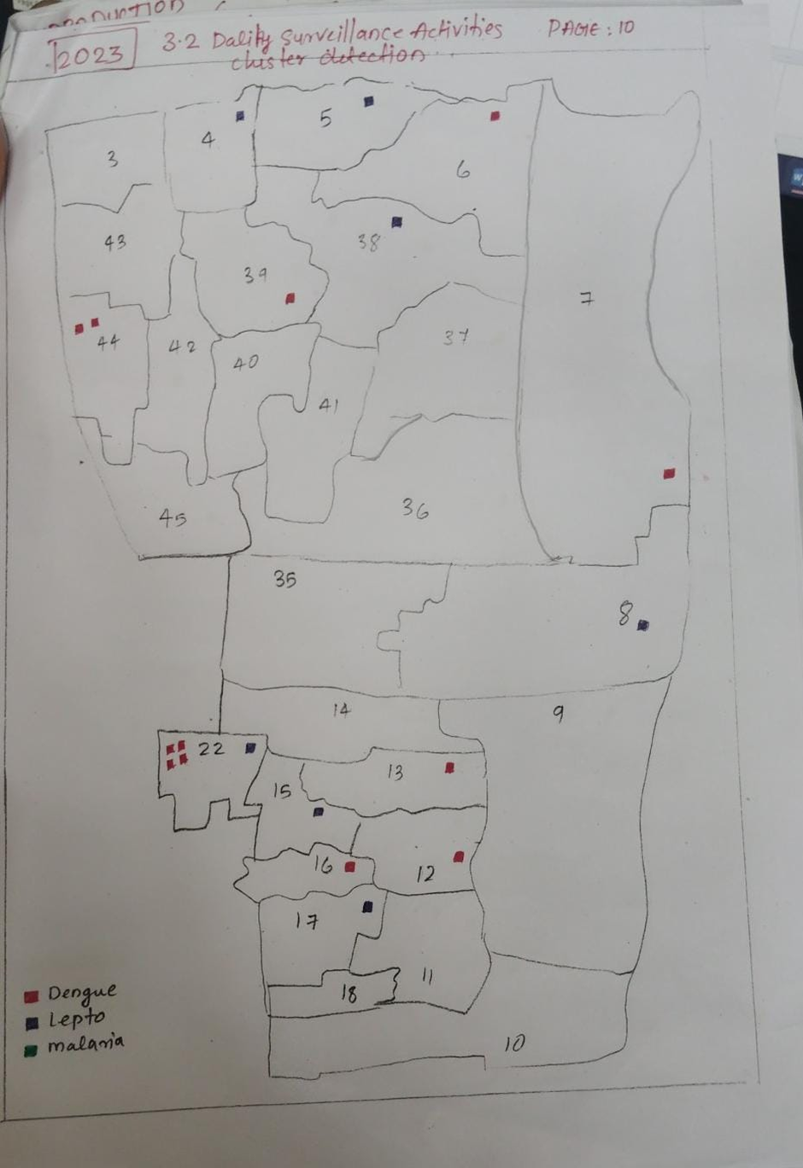

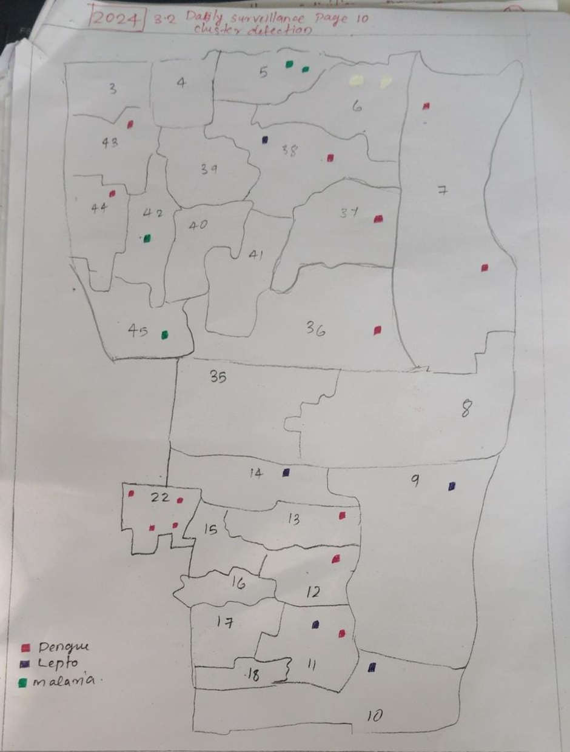
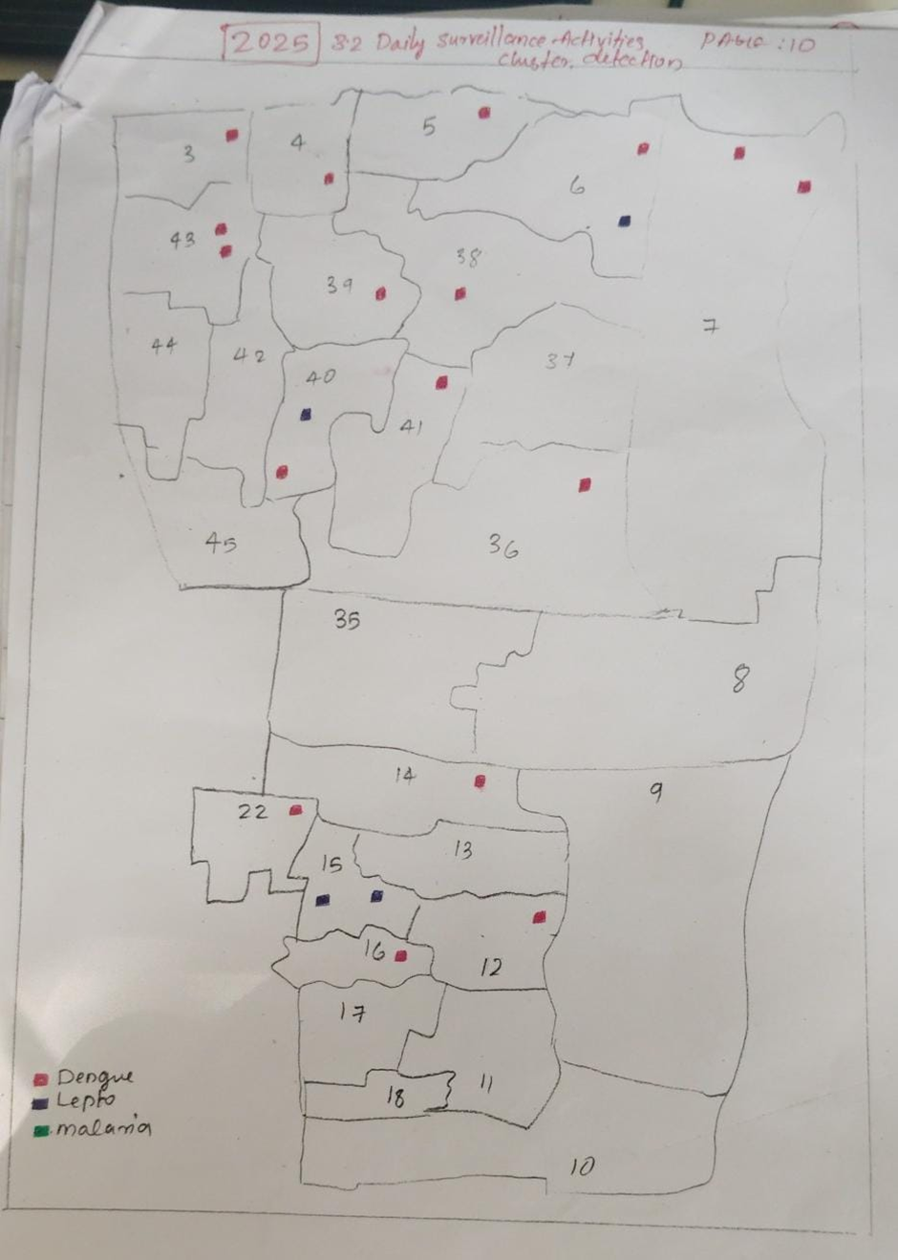

ANNEXURE 9: GH CIRCULAR- ESTABLISHMENT ORDER IN STRIKE

In view of the proposed strike (Bandh / by category of staff) this order is issued to ensure uninterrupted essential medical services and patient safety; the following arrangements are hereby issued to use in need.
All essential services, ICU, Dialysis unit, Casualty services, Blood Bank and Operation theatre will function normally without disruption.

DUTY ALLOCATION
• All available doctors, Nursing staff, Paramedical staff, security and ambulance staff are directed to report for duty as per the revised duty registers.
• RMO will put the revised duty orders for the doctors and ARMO will assist in the duty posting.
• Nursing Superintendent will ensure duty posting at wards and all essential service areas.
• Nursing Superintendent will coordinate posting with Deputy Nursing Superintendent
• Ensure security staff and ambulance drivers are working without affecting the services.
• The Lab-in-charge, Radiology-in-charge, Blood bank-in-charge and Pharmacy-in-charge will prepare emergency duty roster of lab technicians, radiographers, blood bank technicians and pharmacists and submit the same to medical Superintendent.
• Store Superintendent/ PSK will ensure uninterrupted supply of medicines.

LEAVES
All kinds of leave stand cancelled during strike period, except in case of extreme medical emergency. Unauthorized absence will be treated as medical emergency.

OUTPATIENT SERVICES
Outpatient services will be functioning with limited capacity depending on staff availability. Functioning will be done in such a way that all elderly patients, children and emergency referrals will be taken care of.

PATIENT COMMUNICATION
Display notices shall be placed permanently informing patients about limited services and directing emergency cases to designated areas.

ANNEXURE 10: TRIAGE POLICY – HOSPITAL
1. Purpose
To ensure rapid assessment, categorization, and prioritization of patients according to the
severity of illness or injury, so that timely and appropriate treatment is provided, optimizing
available resources and patient outcomes.
2. Scope
Applicable to all patients arriving in the Emergency Department (ED), during disaster
situations, and in mass casualty incidents (MCI).
3. Policy Statement
All patients presenting to the emergency shall undergo Triage within 5 minutes of arrival. The
process shall be conducted by trained triage personnel using the Triage Colour Code System.
Categories determine treatment priority and resource allocation.
4. Definitions
Triage: The process of sorting patients based on the urgency of their medical needs to ensure
the most effective use of available resources.
5. Triage Colour Code Categories
Colour Code Category
Description
Examples
Red
Immediate
Action
Life-threatening condition Major trauma, cardiac arrest Immediate resuscitation
Orange
Yellow
Green
Black
Very Urgent
Urgent
Non-Urgent
Serious but not immediately life-threatening
Fractures with bleeding, respiratory distress
Treatment within 10–15 min
Stable but requires attention Mild asthma, moderate pain Seen within 30 min
Minor illness/injury
Deceased/Expectant
Minor cuts, sprains
No signs of life / unsurvivable injury
Seen after higher categories
No pulse after resuscitation Move to mortuary
6. Triage Process
On Arrival: All patients are assessed at the Triage Desk by a trained nurse or medical officer
for Airway, Breathing, Circulation, level of consciousness, vital signs, and chief complaint.
Categorization: Assign colour code, document in Triage Form/Register, and direct patient to
appropriate treatment area.
Re-triage: Re-evaluate patients periodically, especially if waiting exceeds 30 minutes or
condition worsens.
7. Roles and Responsibilities
Role
Responsibility
Triage Nurse / Medical Officer
Perform triage, assign colour code, ensure documentation
Emergency Medical Officer (EMO)Supervise triage and re-triage process
Casualty Medical Officer (CMO) Ensure timely management of red/orange category patients
Hospital Administrator
Provide infrastructure, resources, and training
Quality Assurance Officer
8. Documentation
Audit triage performance quarterly
Maintain a Triage Register with patient details, arrival time, triage category, initial assessment,
and signature of triage staff. Review monthly for quality monitoring.
9. Training
All emergency staff must undergo triage protocol training annually, including mock drills and
mass casualty simulation exercises.
10. Quality Indicators
• Time from arrival to triage ≤ 5 minutes
• Red category response ≤ 1 minute
• Re-triage accuracy ≥ 90%
• Documentation completeness ≥ 95%
11. References
• National Disaster Management Authority (NDMA) Guidelines – Hospital Preparedness
• MOHFW Emergency Care Framework, India
• WHO ETAT Guidelines
• NABH 5th Edition Standards
12. Review
This policy shall be reviewed annually or after any major drill or incident

ANNEXURE 11 : INFECTION CONTROL POLICY
HOSPITALINFECTIONCONTROLCOMMITTEE

NO | NAMEOFTHE MEMBERS | DESIGNATION | POSITION | PHONE NUMBER
1. | DR.SANDHYA R | SUPERINTENDENT | CHAIRMAN | 9744140055
2. | DR.VENUGOPAL K | DY.SUPERINTENDENT | CONVENOR | 9447162224
3. | DR.ASHA M | RMO | MEMBER | 9847794133
4. | DR. PRIYADARSAN C.P. | ARMO | MEMBER | 9656900375
5. | DR. SETHU K.P. | ARMO | MEMBER | 9496161977
6. | DR. PRIYADARSAN C.P. | LAB I/C | MEMBER | 9656900375
7. | DR. SREEKUMAR V. | CONSULTANT- ANASTHESIA | MEMBER
8. | DR. SHAMEER | JUNIOR CONSULTANT- B. BANK | MEMBER | 8907777246
9. | DR. DEEPA | MICROBIOLOGIST | MEMBER
10. | Dr. ANUPAMA R | CONSULTANT- PEDIATRICS | MEMBER | 9847121218
11. | SRI. SABU T. | LAY SECRETARY & TRESURER |  | 9400486069
12. | SMT. JAYA K.K. | NURSING SUPERINTENDENT | MEMBER | 9446868113
13. | SMT. SUNITHA SEBASTIAN | SENIOR LAB TECHNICIAN | MEMBER | 9288607972
14. | SMT. AMBILI | NURSING OFFICER | MEMBER
15. | SRI. PTER T.S. | JHI | MEMBER | 9497515190
16. | SRI. BENNY ALOCIUS | PRO | MEMBER | 9645093850
17. | SMT. SWAPNARANI V. J | PHARMACIST GR-I
18. | SRI TOMS ARAKKAL | RADIOGRAPHER |  | 9061610880
19. | SMT. PRAMEELA | JPHN |  | 8943317099
20. | SMT. JAYANTHI | NURSING ASSISTANT
21 | SRI. SATHEESHKUMAR | HOSPITAL ATTENDENT GR-I
22 | SRI. BIJUMON | HOSPITAL ATTENDENT GR-Ii

ANNEXURE 12: DEAD BODY MANAGEMENT POLICY

DEAD BODY HANDLING POLICY DURING PANDEMIC PREPAREDNESS

Purpose
To ensure safe, respectful, and infection-controlled handling of deceased bodies during a pandemic while protecting healthcare workers, relatives, and the community from disease transmission.

Scope
Applies to:
- All hospital departments
- Blood centre staff (if handling donor or in-hospital deaths)
- Mortuary staff
- Nursing staff
- Housekeeping & sanitation workers
- Security personnel
- Ambulance services

Responsibility
Role | Responsibility
Medical Officer | Certification of death, infection risk classification
Nursing Staff | Body preparation and documentation
Infection Control Team | Training, PPE guidance, monitoring
Mortuary Staff | Storage, labelling, transfer
Housekeeping | Area disinfection, waste disposal
Security | Controlled access of relatives
Administration | Logistics, PPE availability

Risk Classification of Dead Body
Category | Examples | Risk Level
High Risk | COVID-like illness, viral haemorrhagic fevers, unknown infectious cause | High
Moderate Risk | Confirmed infectious disease but low transmission risk | Moderate
Low Risk | Non-infectious deaths | Low

General Principles
- Treat all bodies as potentially infectious
- Maintain dignity and cultural sensitivity
- Minimize handling and manipulation
- Follow Standard Precautions + Transmission-Based Precautions
- Restrict crowding and public viewing

PPE Requirements
Activity | PPE Required
Body preparation | N95 mask, gloves (double), gown/coverall, face shield/goggles, shoe cover
Transport | Gloves, mask, gown
Cleaning/disinfection | Gloves, heavy-duty gloves over medical gloves, mask, apron

Procedure for Handling the Body

Immediately After Death
- Perform hand hygiene
- Staff wear full PPE
- Remove all lines, tubes, catheters (unless medico-legal case)
- Disinfect puncture sites with 1% sodium hypochlorite

Body Preparation
- Plug oral, nasal, and wound openings with disinfectant-soaked gauze
- Avoid embalming during high-risk pandemics
- Do not wash the body unless required by protocol
- Cover body with sheet

Body Bagging
- Place in leak-proof body bag
- Disinfect outer surface with 1% sodium hypochlorite
- Attach identification label:
  - Name
  - Age/Sex
  - Hospital ID
  - Infection status

Transfer to Mortuary
- Use designated route
- Avoid public areas
- Staff in PPE
- Mortuary log entry mandatory

Viewing by Relatives
- Limited number of relatives (as per hospital policy)
- No touching/kissing
- Relatives must wear mask and gloves
- Maintain physical distance
- Duration restricted

Post-mortem Examination
- Only if legally required
- Conduct in negative-pressure autopsy room if available
- Aerosol-generating procedures minimized

Cleaning & Disinfection
Area | Disinfectant
Bed, surfaces | 1% sodium hypochlorite
Equipment | 70% alcohol or approved disinfectant
Floor | Hypochlorite solution
Waste disposal as Biomedical Waste – Infectious Category.

Linen Handling
- Avoid shaking
- Place in biohazard bag
- Wash at high temperature with disinfectant

Transportation Outside Facility
Inform public health authority (if notifiable disease)
- Ambulance staff in PPE
- Body not reopened after sealing
Staff Safety Measures
- Mandatory PPE training
- Vaccination (if available)
- Exposure reporting system
- Psychological support for staff

Documentation Required
- Death summary
- Infection status note
- Body handover form
- Mortuary register entry
- Disinfection checklist

Cultural & Religious Considerations
Allowed if not increasing infection risk:
- Prayer rituals without contact
- Viewing from distance
- Sealed coffin recommended

Training & Mock Drills
- Annual training
- Pandemic simulation drills
- Audit by Infection Control Committee

Policy Review
Reviewed:
- During outbreak updates
- Annually otherwise

